BEN-GURION UNIVERSITY OF THE NEGEV
FACULTY OF ENGINEERING SCIENCES
DEPARTMENT INDUSTRIAL ENGINEERING AND MANAGEMENT

Integrated Analysis and Optimization of Existing and Projected National Environmental Footprints System

THESIS SUBMITTED IN PARTIAL FULFILLMENT OF THE REQUIREMENTS FOR THE M.Sc DEGREE

By: Dor Chen

Supervised by: Prof. Raziel Riemer and Prof. Meidad Kissinger

September 2025

BEN-GURION UNIVERSITY OF THE NEGEV
FACULTY OF ENGINEERING SCIENCES
DEPARTMENT INDUSTRIAL ENGINEERING AND MANAGEMENT

Integrated Analysis and Optimization of Existing and Projected National Environmental Footprints System

THESIS SUBMITTED IN PARTIAL FULFILLMENT OF THE REQUIREMENTS FOR THE M.Sc DEGREE

By: Dor Chen

Supervised by: Prof. Raziel Riemer and Prof. Meidad Kissinger


Author: Dor Chen Date: 29.09.2025

Supervisor: Prof. Raziel Riemer Date: 29.09.2025

Supervisor: Prof. Meidad Kissinger Date: 29.09.2025

Chairman of Graduate Studies Committee: Prof. Gilad Ravid Date: 30.09.2025

September 2025

Abstract
Climate change mitigation requires rapid decarbonization of national power systems, yet the available pathways are strongly conditioned by structural economic, spatial, and environmental constraints. Israel provides a critical case study, combining rapid demographic growth with ambitious climate targets and severe land limitations. Building on a general sustainability framework, this thesis develops an optimization-based electricity system model with hourly resolution (~245,000-time steps, 2023–2050). The problem is formulated as a large-scale linear program (LP) that minimizes cumulative greenhouse gas emissions subject to constraints on land availability, system cost, ramping, and storage dynamics.
The results consistently show that solar photovoltaics and battery storage act as the primary enablers of high renewable penetration, while gas-fired generation remains as a residual balancing resource. Renewable shares of approximately 70–80% are found to be technically feasible and economically efficient under current assumptions. Pushing renewable penetration beyond roughly 90% requires disproportionately larger expansions of infrastructure and solar land, accompanied by rising system costs and increasing levels of curtailment. In terms of direct system costs alone, fossil-dominated configurations appear significantly cheaper than high-renewable systems. However, when external costs associated with air pollution and greenhouse gas emissions are explicitly accounted for, the total cost of fossil-based pathways rises to levels comparable with those of systems achieving close to 90% renewable penetration. This finding highlights that apparent cost advantages depend strongly on cost composition and accounting assumptions, rather than on total expenditure levels alone.
To focus the analysis on economically plausible system configurations, the study further examines a subset of scenarios characterized by relatively low average system cost within each renewable penetration range. This comparison shows that cost efficiency primarily constrains the overall scale of the system, such as the required infrastructure and capacity expansion, rather than its fundamental composition. Across cost-efficient solutions, the dominant role of solar generation, battery storage, and gas-based balancing remains consistent, while differences in system cost are mainly driven by the extent of deployment rather than by technology substitutions.
Sensitivity analysis further identifies the joint availability of budget and solar land as the key limiting factors for achieving very high renewable shares. The results indicate that around a renewable penetration level of 90%, corresponding to approximately 700–900 km² of allocated solar land from a possible range of 450 to 900 km² and system cost ceilings on the order of (8–10)×10¹¹₪, from a possible range of 7 to 11.5 ×10¹¹₪ relaxing either constraint in isolation is insufficient to enable substantially higher renewable shares. Beyond this point, additional budget without land expansion, or additional land without corresponding financial flexibility, yields only marginal improvements, underscoring the coupled nature of economic and spatial constraints in deep decarbonization pathways. The contributions of this thesis are threefold. Methodologically, it demonstrates how optimization-based electricity models can extend footprint-oriented sustainability frameworks into operational decision-support tools. Empirically, it provides original system-level insights into Israel’s electricity transition under multiple interacting constraints. Analytically, it clarifies the joint role of land, cost, and emissions in shaping feasible and cost-efficient decarbonization pathways. More broadly, the findings indicate that while deep decarbonization of the electricity sector is technically achievable, its success depends on coordinated spatial planning, large-scale storage deployment, and consistent accounting of environmental externalities. Although Israel represents a relatively small national system, its structural characteristics — limited land availability, rapid demand growth, and ambitious decarbonization targets — mirror constraints increasingly faced by densely populated and land-constrained countries worldwide. As such, the Israeli case provides a structurally relevant prototype for understanding deep decarbonization pathways under spatial scarcity.
Keywords: Energy transition, Electricity sector, LP optimization, Renewable integration, Land constraint, Battery storage, Curtailment, Policy implications, Emissions accounting, Sensitivity analysis

Acknowledgments
I wish to express my deepest gratitude to my two advisors.
To Professor Raziel Riemer, thank you for your invaluable guidance, your patience, and your unwavering support throughout these years of work. In challenging times like these, I would not have managed without your steadfast support in me. Your insights, your high standards, and your encouragement shaped both this thesis and me as an engineer. To Professor Meidad Kissinger, thank you for your expertise, your constructive feedback, and your perspective, which broadened my understanding of the field and strengthened this research.
To my lab friends and colleagues, thank you for the many hours we spent together thinking, laughing and sharing challenges together. Thank you and for the countless moments of encouragement and friendship.
I would like also to thank the department members for their teaching, advice, and inspiration over the years, as well as the administrative staff for their dedication and efficiency, and the technical staff for their continuous support and problem-solving skills that helped keep everything moving forward.
To my parents, thanks for your endless love and for everything you have given me throughout the years, which provided me with the foundation and strength to continue this path. Above all, to my beloved wife Yael, thank you for your inspiration and for your unstoppable support during such complex years. To my two sweet children, Avigail and Nave, thank you for being my anchor and my greatest source of joy. Your smile, love, and presence gave meaning to every step of this journey. I hope that this work, in some small way, will help make your world better.

Table of Contents
Abstract 0
Table of Contents 3
1.Introduction 5
2.Method 8
2.1 The General Framework Model 8
2.2 Improvements – Simplified water model 10
2.3 Optimization model 12
2.4 Integration with External Models 20
3.Results 22
3.2 System feasibility space: land, cost and renewable penetration 24
3.3 Statistical relationships between key system indicators 26
3.4 Energy balance and demand coverage in 2050 28
3.5 Cost efficiency and system cost structure in 2050 – selected scenarios 29
3.6 Emissions in 2050 by source - selected scenarios 31
3.7 Installed capacities and infrastructure scale in 2050 – selected scenarios 33
3.8 Refined statistical relationships in the average system cost selected solution space 38
4.Discussion 39
4.1 Land and emissions as joint binding constraints 40
4.2 Economic efficiency and sensitivity to system constraints 41
4.3 Policy implications and system-level insights 44
4.4 Consistency with national-scale electricity planning studies 46
4.5 Limitations 47
4.6 Future research 49
5.Conclusions 50
6.References 52
Appendix 55

List of Figures
Figure 1 - Model scheme showing the inputs (left-hand side) and outputs from Cordova et al. (2024), 10
Figure 2- Water Scheme Model 12
Figure 3 - Integration of External Models with the General Framework 21
Figure 4 Generation mix, hourly resolution, winter week (January 2030) 22
Figure 5 - Generation mix, hourly resolution, summer week (June 2030) 23
Figure 6 Generation mix in hourly resolution 2030 55.6 RE% 24
Figure 7 - Feasible renewable penetration in 2050 as a function of system cost and solar land availability (3D mesh) 25
Figure 8 - Total emissions by source over all years, stacked, across all scenarios sorted by renewable share in 2050 26
Figure 9 - Pearson correlation matrix across all 101 modeled scenarios 27
Figure 10 Annual electricity demand coverage and generation mix in 2050 across all scenarios, 11.2% scenario is appliying currnet grid mix to 2050 28
Figure 11 - Average system cost in 2050 (NIS/kWh) for the selected scenarios 29
Figure 12 - Annual system cost in 2050 decomposed by source (OPEX + CAPEX + externalities) for the selected 31
Figure 13- Emissions in 2050 by generation source for the selected scenarios 32
Figure 14 - Total emissions in 2050 by source across all modeled scenarios sorted by renewable share 33
Figure 15 – Installed generation and storage capacities in 2050 across selected scenarios 34
Figure 16 - Battary Capacity 2050 4H model 35
Figure 17 - Battery energy level in winter 2050 36
Figure 18 - Battety energy level in winter 2050 36
Figure 19 - Installed capacity evolution across the planning horizon for a representative 90 RE% scenario 37
Figure 20 - Pearson correlation matrix across 13 selected scenarios 39
Figure 21 - Budget-only sensitivity of renewable share in 2050 (base scenario) 41
Figure 22 - Land-only sensitivity of renewable share in 2050 (base scenario) 42
Figure 23 - Joint budget and land sensitivity of renewable share in 2050 (base scenario) 43
Figure 24 - Average system cost in 2050 versus carbon intensity in 2050 for selected scenarios 45
Figure 25 - Correlation network 59

List of Tables

Table 1 - Battery discharge event statistics in 2050 across selected scenarios 38

Introduction
Climate change is one of the defining challenges of the 21st century. The most recent Intergovernmental Panel on Climate Change (IPCC, 2023) assessment confirms that global mean surface temperatures have already risen by approximately 1.1°C above pre-industrial levels, primarily due to anthropogenic greenhouse gas emissions from fossil fuel combustion, land-use change, and industrial processes. Without rapid and far-reaching mitigation, the world is projected to overshoot the 1.5°C target enshrined in the Paris Agreement, with severe consequences for ecosystems, water resources, human health, and economic stability (Rockström et al., 2009; IPCC, 2023). Central to this challenge is the energy sector, the dominant source of global greenhouse gas emissions (IEA, 2022). Decarbonizing electricity systems is therefore both a global imperative and a prerequisite for economy-wide net-zero transitions.

To quantify environmental pressures and evaluate mitigation pathways, scholars have developed a range of footprint-based frameworks. The ecological footprint approach, pioneered by Wackernagel and Rees (1996), provided one of the earliest system-level metrics for assessing human demand relative to the planet’s biocapacity. Later work introduced specialized measures such as the carbon footprint (Wiedmann and Minx, 2008), water footprint (Hoekstra et al., 2011), and land footprint (Weinzettel et al., 2013). These indicators, typically grounded in life-cycle assessment (LCA) and material flow analysis (MFA), capture specific environmental dimensions and allow consistent accounting across scales. However, as the literature emphasizes, conventional footprint accounts have often been static and retrospective, and they may obscure displacements through trade, thus offering limited guidance for shaping future-oriented policy (Lenzen et al., 2007; Steen-Olsen et al., 2012).

To bridge this gap, recent research has increasingly embedded footprint analysis within scenario-based modeling and optimization frameworks. Scenario analysis enables exploration of alternative demographic, technological, and policy futures, while optimization provides a rigorous mathematical means to identify system configurations that minimize or balance impacts under constraints. Conceptually, the relationship between footprints and LCA has been clarified, providing a foundation for integrated modeling (Fang and Heijungs, 2015). Concrete applications increasingly combine footprint accounting with multi-objective optimization; for example, Li et al. (2020) applied an EF-based multi-objective optimization to assess cropland-use sustainability. In parallel, nexus studies synthesize cross-sector linkages among water, energy, and food systems and inform scenario design (Zhang et al., 2018). Mixed-Integer Linear Programming (MILP) has become a standard framework for designing least-cost or least-emission generation portfolios subject to operational and policy limits (Poncelet et al., 2016). At the same time, several large-scale long-term planning models adopt linear optimization formulations to balance temporal resolution, scenario breadth, and computational tractability (Deng & Lv, 2020). Methodological work has also emphasized transparency and reproducibility in energy-system optimization, advocating open data and open code practices alongside established frameworks such as MARKAL/TIMES (DeCarolis et al., 2020). This represents a paradigm shift: footprints are no longer treated solely as ex-post indicators, but also as active objectives and constraints within planning models.

Israel provides a compelling case for applying such approaches. The country faces rapid demographic growth, ambitious climate commitments, and severe land and water constraints. Population is projected to rise from 9.8 million in 2023 to more than 16 million by 2050 (CBS, 2019). At the same time, per-capita electricity demand is steadily increasing, while national policy targets a net-zero electricity sector by mid-century. Yet, as the Israel Electricity Authority’s Net Zero Outlook (NZO, 2021; 2023) emphasizes, the pathways to achieving these targets are fraught with trade-offs. Solar photovoltaics (PV) and battery storage are expected to dominate capacity expansion, but land availability is limited to roughly ~850 km² (NZO Part B, 2021). In practice, this land envelope may include a combination of single-use and dual-use applications. However, in this study both categories are treated uniformly as a single land constraint to simplify the model structure and focus on system-level trade-offs. The NZO warns that under baseline assumptions, renewable penetration may be below official goals, unless structural measures such as nuclear deployment or demand-side interventions are implemented. These challenges underscore the need for optimization-based approaches that can reconcile emissions reduction, cost control, and land management in an integrated framework.
Beyond its specific national context, Israel serves as a structurally informative case for other land-constrained and densely populated countries seeking deep decarbonization. As renewable-dominated systems require substantial spatial allocation, countries with limited territory face sharper trade-offs between land use, infrastructure scale, and emissions reduction. Studying such a system therefore provides insight into structural constraints that may become increasingly relevant in densely populated regions.

A foundational contribution in this direction was made by Cordova (2023), who developed a comprehensive national-scale sustainability model for Israel. That framework integrated population growth, energy demand, food consumption, water use, and land occupation into a consistent footprint accounting system, producing projections across multiple scenarios. By disentangling the contributions of demographic growth, rising per-capita consumption, and mitigation measures, the model demonstrated that while technological and behavioral interventions (e.g., renewable deployment, dietary shifts, transport efficiency) can substantially reduce pressures, demographic expansion remains the dominant force driving future increases in land, water, and GHG footprints. A subsequent publication (Cordova et al., 2024) reinforced this conclusion, showing that even advanced technological pathways cannot deliver net-zero emissions by 2050 if demographic expansion is not addressed. Their analysis highlighted the critical need to incorporate demographic realities into energy and resource planning.

Building on this foundation, the present thesis advances the analysis by focusing on the electricity sector, Israel’s single largest source of greenhouse gas emissions, and by raising the temporal and technical resolution of the modeling. Specifically, it refines the general framework into an optimization-enabled tool, representing electricity generation, storage, and curtailment with hourly granularity (~245,000 hours over 2023–2050). This allows explicit treatment of variability in solar generation, operational constraints of storage, and ramping dynamics of thermal plants, where "ramping" refers to limits on the rate at which new capacity can be added or existing plants can increase or decrease output. By framing the problem as a large-scale linear programming, the model endogenously determines capacity additions and generation mixes that minimize cumulative emissions subject to land, budget, and ramping constraints. In doing so, the framework evolves from scenario exploration to optimization-based decision support, directly informing policy debates on feasible pathways for Israel’s electricity transition.

From this motivation, the thesis addresses three guiding research questions:

- The effect of available land, budget, on the feasible electricity mix in Israel when optimizing for minimum greenhouse gas emissions towards net-zero?

- Quantitative analysis of the trade-offs between cost, emissions, and renewable penetration when optimizing the system at hourly resolution?

- How do key modeling assumptions and structural constraints influence capacity expansion trajectories and renewable integration outcomes?

The contributions of this thesis are threefold. Methodologically, it extends existing sustainability frameworks by implementing an optimization with hourly granularity and time-varying emission factors. Empirically, it produces projections for Israel’s electricity sector ability to change to relying mostly on renewable energy, will quantifying the effect of the available budget and land area use. By combining global perspectives with a detailed national case study, the thesis aims to generate insights of both scientific and policy relevance.

The remainder of this thesis is organized as follows. Chapter 2 presents the methodological foundations: first, the general framework model developed by Cordova; second, the improvements introduced here, particularly in the electricity module; third, the integration with the NZO platform through an API for cost and emissions data; and finally, the optimization model extending the framework to hourly resolution. Chapter 3 reports the results, including baseline trajectories, scenario outcomes, and optimization outputs. Chapter 4 provides the discussion, situating the findings within broader policy and academic contexts. Chapter 5 concludes with key insights, limitations, and recommendations for future research. References are listed in Chapter 6, and the Appendix provides supplementary material, including mathematical formulations, parameter tables, and validation checks.

Method

2.1 The General Framework Model
The general model, as developed in Cordova’s thesis and in "Effects of demographic and technological trends on the mitigation of Israel’s
environmental footprint" by Cordova et al. (2024), establishes a national-scale framework to evaluate Israel’s environmental footprint across multiple consumption sectors. The model was implemented in MATLAB, with baseline data collected and organized in Excel spreadsheets that serve as the input foundation for the simulations.

The model uses baseline data for the year 2017, including population size, energy generation by source, transportation mileage, food and water consumption, and construction activity. These baseline values combined with equations for trends enable projecting future demands and environmental impacts.
These trends are demographic growth, increased per-capita electricity use, changes in transportation mileage, and projected reliance on desalinated water. These trends are based on official national statistics data and international projections (Central Bureau of Statistics of Israel, Ministry of Energy, Water and Transportation, 2017(.
To evaluate mitigation potential, the model defines a set of factors and scenarios. Factors represent technological or behavioral measures—such as expansion of renewable electricity, reduction in food waste, dietary shifts away from beef, and increased use of public transport. Scenarios are combinations of these factors, constructed to represent different levels of ambition: a no-policy baseline, a moderate pathway aligned with government targets, and an advanced pathway reflecting international climate goals.

Several modeling assumptions are embedded in this framework. For example, electricity generation is assumed to rely primarily on solar PV, with improvements in land-use efficiency until 2050; water demand grows with population, with desalination providing an increasing share; and dietary composition is assumed to remain stable except where explicitly altered by mitigation factors. Land, water, and GHG coefficients are derived from life-cycle assessment and material flow analysis and are applied consistently across all categories.

The model outputs are expressed as three environmental footprints: greenhouse gas emissions, land use, and water consumption. These outputs are calculated both on a domestic scale (impacts within Israel’s borders) and on a global scale (embodied impacts from imports such as food or fuel).

Finally, The General Framework model enables analysis of the effect of different factors. Using both single-factor and combined analyses, it disentangles the contribution of population growth, consumption increases, and mitigation measures. Results show that while technological and behavioral measures (renewables, food waste reduction, transportation efficiency) can substantially reduce emissions, demographic growth and rising per-capita demand remain dominant forces driving future increases in land, water, and GHG footprints.

While this general framework provides a comprehensive national-level perspective, it was designed mainly for scenario analysis and lacked certain flexibility for extension and integration. For example, some sub-models, particularly the water module, were based on simplified assumptions and could not fully capture the dynamics required for more detailed analysis. Accordingly, the present work builds upon this foundation by reconstructing the water module, refining specific assumptions, and introducing several improvements that enable further analysis. In addition, the model was adapted to allow integration with external data sources, including a direct API connection to the NZO platform for financial inputs, and was expanded with an optimization component aimed at minimizing emissions. 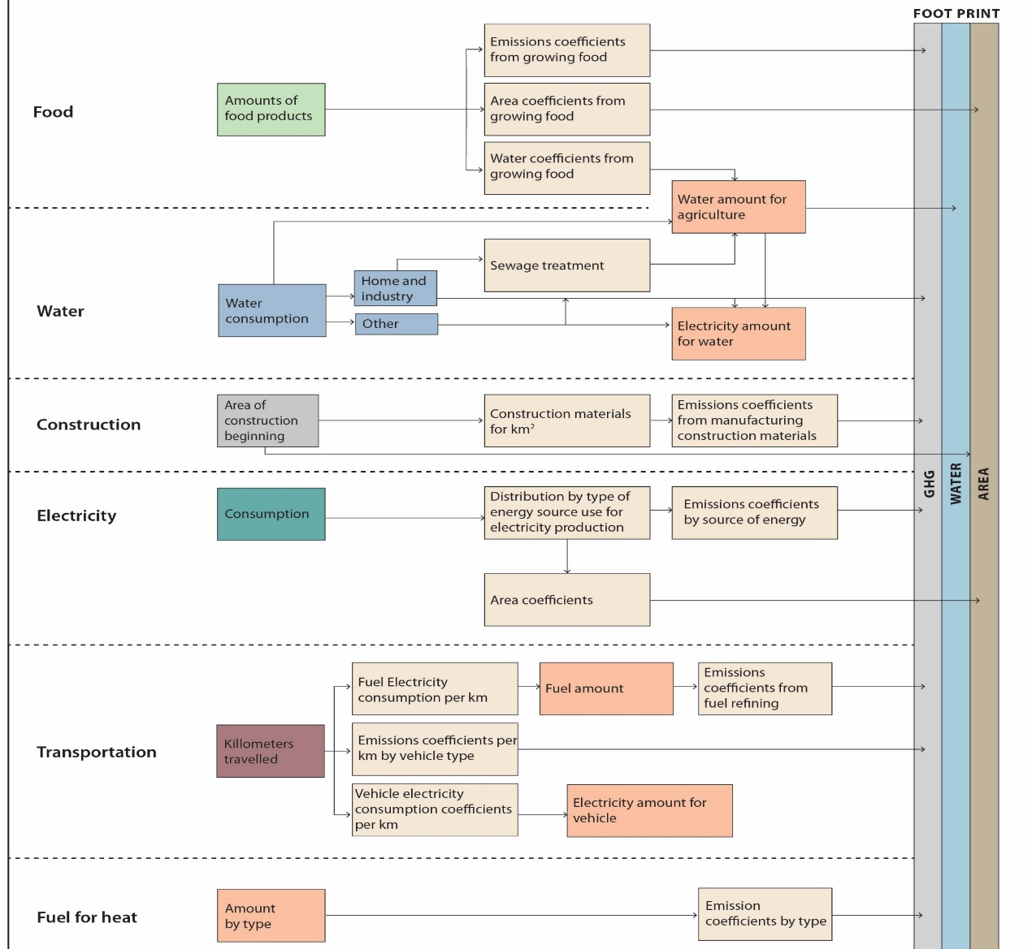
Figure 1 - Model scheme showing the inputs (left-hand side) and outputs from Cordova et al. (2024),

2.2 Improvements – Simplified water model
The water model for Israel developed to provide a simplified yet comprehensive representation of the national water system, enabling projections of demand, supply, and related environmental impacts up to 2050. The model implemented in MATLAB, with Excel-based datasets from the Israel Water Authority, the Central Bureau of Statistics, and Mekorot serving as the baseline inputs. Its structure is based on a clear mapping of consumers and suppliers, where balance between the two sides ensures that projected demand consistently met by adequate supply.

Model Assumptions. Several key assumptions underpin the framework. It's assumed that supply always meets demand, with desalination bridging any gaps. Agricultural demand projected to grow proportionally with population, while the share of freshwater allocated to agriculture remains fixed at approximately 35% of total use. Natural freshwater availability is expected to decline by 25% by 2050 due to climate-driven reductions in precipitation and recharge rates. Wastewater reuse fixed at 66% of household and industrial freshwater use. Water supply to neighboring countries increases with Palestinian population growth, while brackish and reservoir water use is held constant at ~250 million cubic meters (MCM) annually. Physical losses (“depreciation”) modeled as 3% of consumption, while external shocks such as price changes, imports, exports, or geopolitical events excluded.

Consumers. Four major categories of consumers are defined: (1) domestic and industrial consumption, stable at ~110 m³ per capita annually; (2) agricultural consumption, modeled per capita, with recent declining trends incorporated into the projections (~136 m³ per capita, with 65% supplied by non-freshwater); (3) water supplied to neighbors, governed by agreements with Jordan (currently 90 MCM) and variable Palestinian allocations based on demographic growth; and (4) water returned to nature, approximated at 1% of demand using schematic forecasts from Mekorot.

Suppliers. Water supply is derived from: (1) desalination, acting as the balancing factor to ensure demand is met; (2) natural freshwater, projected to decline linearly by 25% to 2050; (3) treated wastewater, maintained at 66% reuse; and (4) brackish and reservoir water, fixed at 250 MCM per year.

Mathematical Representation.
The central assumption is:
$$D\left(t\right)+G\left(t\right)+W\left(t\right)+B(t)=H\left(t\right)+A\left(t\right)+F.N\left(t\right)+T.N\left(t\right)$$
where D(t) is desalinated water, G(t) groundwater, W(t) treated wastewater, and B(t) brackish and reservoir water; while on the demand side, H(t) is domestic and industrial consumption, A(t) agriculture, F.N(t) water for neighbors, and T.N(t) water for nature.

Model Validation. The model validated against real-world data for 2020. For example, predicted agricultural water use in 2020 was 1,260 MCM compared to the actual Water Authority figure of 1,195 MCM – a difference of only 5.4%. Similarly, predictions for domestic and industrial use matched observed data almost exactly. This validation indicates that the simplified framework is robust enough to capture key dynamics of Israel’s water system.

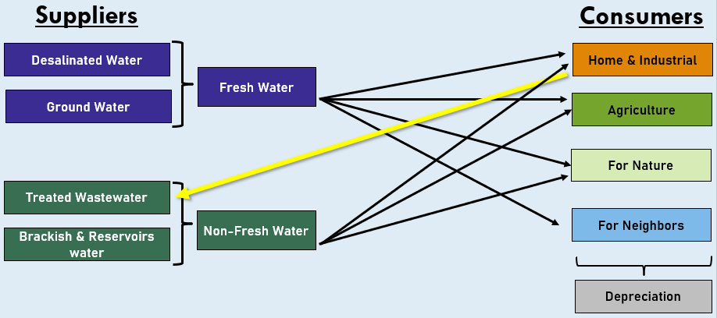
Figure 2- Water Scheme Model

2.3 Optimization model

Case Study and Scope
The optimization problem focuses on Israel’s national power system over a multi-year horizon (2023–2050), with 2050 serving as the benchmark year for evaluating long-term outcomes. The year 2050 is widely adopted in international and national energy planning frameworks as a milestone for deep decarbonization, including the Paris Agreement and multiple Net Zero strategies. Farming the analysis around this target year therefore allows for direct alignment with established policy objectives and comparability with other studies.
Hourly electricity demand is derived from real load data (Noga - Israel Independent System Operator, 2023) as the based demand and extended using the total predicted yearly demand form Cordova et al. (2024), for the entire horizon (~245,000 hours). Using an hourly resolution ensures that both seasonal and intraday variability are accurately represented. This level of granularity captures critical dynamics such as peak loads, renewable intermittency, and the operational role of battery storage—features that coarser annual or daily averages cannot reliably reflect. Moreover, it enables policy-relevant insights that are specific and actionable, such as the timing of potential shortages or surpluses, rather than only high-level trends.
Five technologies are represented: nuclear, solar PV, natural gas, coal, and battery storage. Initial installed capacities correspond to 2023 values (5.9 GW solar, 11.7 GW gas, 5.6 GW coal, 0.37 GW battery, and 0 GW nuclear). Costs, emission factors, and technical parameters were collected from multiple sources including the ROTH Model, NREL, Israel Electricity Authority, Lazard cost reports, and NZO datasets. Notably, life-cycle emission factors for solar and battery are treated as time-dependent, reflecting upstream decarbonization trends. Solar expansion is limited by a land-use cap of ~850 km² (NZO Part B, 2021).
Electricity demand trajectories are derived from the General Framework Model described in Section 2.1, which defines national-scale scenarios for Israel’s demographic, technological, and behavioral trends. Each optimization run inherits its annual electricity demand levels from one of these framework scenarios—namely the no-policy, moderate, or advanced pathways—thereby ensuring full consistency between the national-level demand drivers defined in the General Framework Model and the electricity system optimization module.
The hourly load profile from is used to preserve the characteristic daily and seasonal demand pattern, while the total annual demand is adjusted each year according to the growth trajectory defined by the corresponding framework scenario. This approach guarantees that the optimization model remains internally coherent with the broader system-level framework from which its demand inputs are derived.
Modeling Environment

To implement the optimization framework, we relied on MATLAB as the primary modeling environment. MATLAB provided a flexible platform for managing large datasets, structuring the scenario workflow, and integrating the solver routines within a reproducible pipeline. Before settling on a final solver, we evaluated several alternative approaches to balance tractability, accuracy, and computational efficiency.
- fmincon / fminunc were first considered, as they are effective tools for continuous optimization problems. However, they were unsuitable for this study due to their inability to handle integer decision variables and the very large number of linear constraints inherent to capacity expansion planning.
- Genetic Algorithms were also explored, given their capacity to handle discrete choices and non-linearities. While they offered some flexibility, they suffered from slow convergence and lacked guarantees of optimality, making them ill-suited for policy-relevant analysis where reproducibility and verifiable results are essential.
- Gurobi Optimizer was ultimately chosen. Gurobi is widely recognized as one of the leading solvers for large-scale linear programming (LP), offering advanced presolve techniques, branching heuristics, and certified optimality. Its barrier method proved particularly well-suited to the scale of this problem, which spanned hundreds of thousands of hourly time steps and multiple interacting constraints.
The adoption of Gurobi ensured that the optimization results were not only computationally efficient but also analytically rigorous. By combining MATLAB’s modeling flexibility with Gurobi’s state-of-the-art LP capabilities, we were able to achieve solutions that are technically robust, reproducible, and directly relevant for informing long-term energy policy.

Methodology Overview

The modeling workflow unfolded through six sequential steps, each designed to translate the conceptual research problem into a solvable optimization framework:
- Demand preparation – Hourly electricity demand was compiled from historical load data, capped where necessary, and extended across the full multi-decadal horizon. This ensured that both seasonal cycles and long-term growth trends were accurately represented.
- Technology parameters – Key characteristics for each generation technology were incorporated, including solar capacity factors, time-varying life-cycle emission factors for PV and batteries, and economic parameters such as CAPEX and OPEX. These inputs provided the empirical foundation for realistic system modeling.
- Technology parameters – Key characteristics for each generation technology were incorporated, including solar capacity factors, time-varying life-cycle emission factors for PV and batteries, and economic parameters such as Capital Expenditures (CAPEX) and Operational Expenditures (OPEX). To accurately reflect the time value of money over the multi-decade planning horizon, the entire economic evaluation framework is discounted to Present Value (PV). Specifically, OPEX is disaggregated into Fixed OPEX (capacity-based) and Variable OPEX (generation-based), both of which are discounted annually at a rate of 6%. Furthermore, CAPEX is annualized and discounted using a Capital Recovery Factor (CRF - 6%). These inputs provided the empirical foundation for realistic system modeling
The hourly solar capacity factor profile is derived from the ROTH model, which in turn is based on NREL photovoltaic performance data for single-axis tracking utility-scale PV systems located in Be’er Sheva, using meteorological conditions representative of the year 2023.
Operational expenditure (OPEX) represents all recurring costs associated with electricity generation and storage, excluding capital investment. These include fixed and variable operation and maintenance costs, fuel expenses where applicable, auxiliary electricity consumption, efficiency losses, and charging–discharging losses for battery storage systems.

Capital expenditure (CAPEX) represents upfront investment costs required to install generation and storage capacity. These include equipment and balance-of-system costs, engineering, procurement and construction (EPC), grid connection, civil works, owner’s costs, and contingency allowances.
Furthermore, construction and generation costs vary over the years according to Net Zero Outlook (NZO) forecasts.
- Variable definition – Decision variables were formulated to represent generation, capacity expansion, installed capacity, storage state, charging and discharging flows, curtailment, and cumulative system cost. Together, these variables capture the operational and investment choices of the system.
- Constraint assembly – A comprehensive set of constraints was introduced to enforce demand balance, investment dynamics, capacity-to-dispatch limits, land and budget ceilings, ramping restrictions, and storage balance. These conditions ensured technical feasibility and policy relevance.
- Objective function – The optimization was designed to minimize cumulative life cycle GHG emissions across the entire horizon, reflecting the central policy priority of deep decarbonization.
- Solution procedure – The problem was formulated as a large-scale LP and solved using Gurobi’s barrier method, ensuring convergence to robust and reproducible solutions.
Taken together, these steps established a transparent and replicable framework that links empirical data, technical assumptions, and policy constraints within a single optimization structure.
The modular structure of the model allows it to be readily adapted to alternative objective functions and policy scenarios beyond those examined in this study.

Mathematical Formulation

This study formulates the long-term evolution of Israel’s electricity system as a large-scale linear optimization problem. The formulation is designed to capture the dominant structural trade-offs governing emissions reduction, capacity expansion, and system feasibility at national scale, while remaining computationally tractable over a multi-decade horizon with hourly resolution. Given the spatial and temporal scale of the problem (≈245,000-time steps), all decision variables are modeled as continuous, yielding a linear program (LP). This choice reflects the focus on system-level behavior rather than micro-level discreteness of individual assets.

Sets and Indices

Let
- $i∈I$denote the set of electricity system components and generation technologies (e.g., nuclear, solar PV, gas, coal, battery storage)
- $t∈\left\{1,…,T\right\}$denote the time index, where each $t$corresponds to an hourly time step
- $T$denote the total number of time steps spanning the planning horizon from 2023 to 2050

Parameters

The model is parameterized using exogenous inputs derived from the general framework model and the Net Zero Outlook datasets. Key parameters include:
- $D_{t}$: electricity demand at time $t$(MWh)
- ${\text{CF}}_{i,t}$: capacity factor for solar technology at time $t$
- $c_{i}^{\text{cap}}$, $c_{i}^{\text{op}}$: capital and operational cost coefficients
- $c_{i}^{cap},c_{i}^{fix_op},c_{i}^{var_op}$: capital, fixed operational, and variable operational cost coefficients, varying over time
- $e_{i,t}$: emissions intensity of generation technology $i$at time $t$
- $L^{max}$: maximum land availability for solar deployment
- $B^{max}$: cumulative system budget,
- $R_{i}$: maximum allowable annual (or daily) capacity expansion rate (ramp constraint)
- $η^{\text{ch}},η^{\text{dis}}$: charging and discharging efficiencies for battery storage
- $H_{batt}$: battery storage duration representing the energy-to-power ratio (hours)
- • $r,CRF_{i},df_{t}$: discount rate, capital recovery factor, and yearly discount factor
- • $RM$: reserve margin multiplier for system reliability
- • $CarbonTax$: monetized cost of external carbon emissions
- • $α_{i}$: must-run minimum capacity fraction for technology $i$
- • $K_{i,0}$: initial installed capacity of technology $i$

Decision Variables

The optimization determines the following continuous decision variables:
- $U_{i,t}≥0$: electricity generation or discharge from technology $i$at time $t$(MWh),
- $Z_{i,t}≥0$: incremental capacity addition of technology $i$at time $t$

Derived Variables
- $K_{i,t}≥0$: installed capacity of technology $i$at time $t$(MW)
- $E_{t}≥0$: state of charge of the battery system at time $t$(MWh)
- ${\text{Ch}}_{t},{\text{Dis}}_{t}≥0$: battery charging and discharging flows
- ${\text{Dump}}_{t}≥0$: curtailed electricity (excess generation)
- $C_{t}≥0$: cumulative discounted system cost up to time $t$ (NIS)

Capacity additions $Z_{i,t}$are modeled as continuous variables. While this abstracts from the discreteness of individual projects, it is appropriate at the national planning scale and ensures numerical tractability over long horizons.

Objective Function

The objective is to minimize cumulative greenhouse gas emissions from electricity generation over the entire planning horizon:

$$min⁡\sum_{t=1}^{T}{\sum_{i∈I}{e_{i,t}}} U_{i,t}$$

This formulation prioritizes emissions minimization subject to physical, economic, and policy constraints, rather than cost minimization alone.
Economic costs, including capital expenditure (CAPEX) and operational expenditure (OPEX), are incorporated within the optimization through the cumulative budget constraint, thereby restricting the feasible solution space rather than directly driving the objective function. In contrast, monetized external cost metrics such as climate damage valuation and end-of-life provisions are evaluated ex-post based on the optimized system configurations and reported as additional comparative indicators.

Constraints

Demand Balance

For every time step $t$, electricity demand must be met by generation:

$$\sum_{i∈I}{U_{i,t}}=D_{t}$$This equality enforces strict hourly supply-demand balance, ensuring that total generation, including storage discharge, exactly meets electricity demand in every time step.
Capacity Constraints

Generation is limited by installed capacity and availability:

$$U_{i,t}≤K_{i,t}∀i,t$$

This constraint prevents dispatch beyond installed capacity and links short-term operation to long-term investment decisions.

Capacity Dynamics

Installed capacity evolves according to incremental additions:

$$K_{i,t}=K_{i,t-1}+Z_{i,t} ∀i,t>1$$

With $K_{i,0}$given as initial capacity.
This recursive structure connects investment decisions in one period to available generation capacity in all subsequent periods.

Ramping Constraints

To reflect real-world construction, permitting, and supply-chain limitations, bounds are imposed on capacity expansion in each period:$$Z_{i,t}≤R_{i}∀i,t$$

These constraints limit the speed at which new generation capacity can be deployed, preventing unrealistically rapid build-out. By restricting expansion rates, the model links long-term investment decisions to physically plausible development trajectories and ensures that decarbonization pathways remain consistent with institutional and logistical constraints.

Battery Dynamics

Battery storage follows standard inter-temporal balance equations:

$$E_{t}=E_{t-1}+η^{\text{ch}}{\text{Ch}}_{t}-\frac{1}{η^{\text{dis}}}{\text{Dis}}_{t}$$

With bounds on state of charge and an initial condition $E_{0}=0$.
This intertemporal balance equation explicitly links consecutive time steps. Electricity charged into the battery at time t increases the stored energy available at time t+1 (subject to charging efficiency), while discharged electricity reduces the stored energy accordingly. This formulation ensures energy conservation across time and enables surplus generation in one period to be shifted to future periods within the battery’s capacity limits.

Land Constraint

Total land occupied by solar installations is bounded:

$$\sum_{t,i∈\text{solar}}{α_{i}}Z_{i,t}≤L^{max}$$

$$α_{solar}⋅K_{solar,t}≤L_{max}$$

Where $α_{solar}$ $α_{i}$converts installed capacity to land use.

Budget Constraint

System costs must not exceed the available budget:
$$\sum_{t,i}{\left(c_{i}^{\text{cap}}Z_{i,t}+c_{i}^{\text{op}}U_{i,t}\right)}≤B^{max}$$This cumulative constraint introduces an economy-wide trade-off between capital expansion and operational expenditures across the entire planning horizon.
Budget Constraint
To reflect the economic realities of long-term infrastructure planning, the system's total costs must not exceed a cumulative budget ceiling ($B_{max}$). Unlike a simple cash-flow sum, the constraint evaluates the Total Present Value (PV) of all system costs over the planning horizon.
The constraint ensures that the sum of discounted annualized Capital Expenditures (CAPEX), Operational Expenditures (OPEX), and external emission costs (Carbon Tax) remains within the budget:
$$\sum_{y=1}^{Y}{d}f_{y}⋅\left(CAPEX_{y}+OPEX_{y}+EXT_{y}\right)≤B_{max}$$
Where for each year $y∈\left\{1,...,Y\right\}$, $df_{y}={\left(1+r\right)}^{-y}$ is the discount factor. To bridge the hourly operational resolution with the annual economic evaluation, let $T_{y}$ denote the set of hours within year $y$, such that $t∈\left[\left(y-1\right)×8760+1,…,y×8760\right]$. The annual cost components are then calculated as follows:
- $CAPEX_{y}$: The annualized investment cost of all active capacities calculated using the Capital Recovery Factor ($CRF_{i}$).
- $OPEX_{y}$: The sum of Fixed OPEX and Variable OPEX. Fixed OPEX is proportional to the installed capacity at the year's end ($K_{i,y⋅8760}$), while Variable OPEX is accumulated over all hourly generation within that year:
$$OPEX_{y}=\sum_{i}{\left(c_{i,y}^{fix_op}⋅K_{i,y⋅8760}+\sum_{t∈T_{y}}{c_{i,y}^{var_op}}⋅U_{i,t}\right)}$$
- $EXT_{y}$: The monetized external costs of greenhouse gas emissions, calculated by aggregating the emissions of thermal sources over the year and multiplying by a carbon price ($CarbonTax$):
$$EXT_{y}=\sum_{i∈\left\{Nuc,Gas,Coal\right\}}{\sum_{t∈T_{y}}{e_{i,t}}}⋅CarbonTax⋅U_{i,t}$$
This constraint introduces an economy-wide trade-off between capital expansion, operational efficiency, and environmental externalities across the entire planning horizon.

Battery power and feasibility limits
Charging and discharging are constrained by both technical ratios and energy availability:

$$ChB(t), U_{\text{bat}}(t)≤\frac{K_{\text{bat}}(t)}{H_{\text{batt}}}$$
Must-run conditions
Gas plants must operate at a minimum fraction $m$of installed capacity, while nuclear plants must run at full capacity:

$$U_{\text{gas}}\left(t\right)≥mK_{\text{gas}}\left(t\right) , U_{\text{nuc}}\left(t\right)=K_{\text{nuc}}\left(t\right)$$

Smart Reserve Margin (System Reliability) To ensure grid reliability under high shares of variable renewable energy, a smart reserve margin constraint was introduced. This constraint mandates that firm dispatchable capacity (nuclear, gas, and coal) must be sufficient to cover the net demand with an additional 20% safety margin ($RM=1.20$). Rather than enforcing this constraint across all hours of the year—which is computationally redundant—it is evaluated during a representative subset of critical hours ($T_{critical}$) for each year. These critical hours are identified dynamically and include the top absolute peak demand hours, as well as the top peak demand hours when solar generation is unavailable (i.e., nighttime).

$$K_{nuc,t}+K_{gas,t}+K_{coal,t}≥RM⋅\left(D_{t}-U_{solar,t}\right) ∀t∈T_{critical}$$

By rearranging the solar generation to the left-hand side, the model inherently guarantees that the combination of firm capacity and available solar generation meets 120% of the peak demand, thus safeguarding against sudden supply shortages

Capacity Expansion Windows (Build Constraints) In reality, large-scale energy infrastructure cannot be commissioned on a continuous, hourly basis. To reflect realistic planning, permitting, and construction cycles, capacity additions ($Z_{i,t}$) are restricted to designated build windows. For solar, gas, coal, and battery storage, capacity can only be added annually (i.e., at the end of every 8760-hour block). Due to the exceptionally long development and construction timelines associated with nuclear power, its capacity additions are restricted to occur only once every 20 years. In all other intermediate hours, the capacity addition variables are strictly constrained to zero:

$$Z_{i,t}=0 \text{for }t∉T_{build}^{i}$$

Where $T_{build}^{i}$ represents the discrete allowable commissioning hours for technology $i$. This constraint prevents unrealistic fractional hourly builds and aligns the model's short-term operational resolution with long-term macroeconomic planning steps

Given that all decision variables are continuous and all constraints are linear, the resulting optimization problem is formulated as a large-scale linear program (LP). This modeling choice prioritizes tractability and system-level insight over micro-level discreteness, which is appropriate for national-scale long-term planning under structural uncertainty.

While Mixed-Integer Linear Programming (MILP) formulations are commonly used in generation expansion planning to represent discrete investment decisions, recent reviews note that large-scale, high-temporal-resolution models are frequently implemented as linear programs to balance model scope and computational feasibility (Deng & Lv, 2020). In this study, representing capacity expansion variables as continuous preserves the structural trade-offs between cost, land use, and emissions that form the core focus of the analysis, while enabling exploration of an extensive scenario ensemble.

All simulations were solved using the Gurobi Optimizer, a widely used commercial solver for large-scale linear and mixed-integer optimization problems. Gurobi was selected due to its numerical robustness, computational efficiency, and broad adoption in energy system planning studies, ensuring stable solution of the high-dimensional hourly model considered here.
The optimization framework is fully parametric and can accommodate alternative demand trajectories, technology cost assumptions, emission factors, and policy constraints without structural modification. While the present study adopts cumulative greenhouse gas emissions as the objective function in order to examine deep decarbonization pathways under economic and spatial constraints, the same mathematical structure can be reformulated to minimize total system cost subject to an emissions cap, or to explore alternative policy objectives through corresponding adjustments to the constraint set. The selected objective therefore reflects the analytical focus of this study rather than an inherent limitation of the modeling framework.
Analyses

Our analysis proceeded in two stages. In the first stage, we constructed a structured grid of scenarios by fixing ramping limits for both solar and battery capacity additions and varying two economy-wide constraints: the total investment budget (₪700×10^9–₪1150×10^9) (₪400×10^9–₪500×10^9) and the land available for utility-scale solar deployment (450–900 km²)(350–850 km²). This factorial design yielded a 10×10 grid of 100 scenarios. To benchmark the extremes, we supplemented this grid targeted fossil-only pathway restricted to gas and coal. Together, this produced a portfolio of 101 scenarios that collectively spanned the relevant design space.

In the second stage, we moved from breadth to depth. To avoid redundancy and concentrate on the most policy-relevant contrasts, we grouped scenarios by their achieved share of renewables in 2050. Within each group we retained only the lowest-cost design, thereby tracing an empirical Pareto frontier that represents the minimum expenditure required for each renewable share level. This systematic filtering ensured that subsequent analyses focused exclusively on non-dominated scenarios. To this refined set we added sensitivity variants, alongside the fossil-only benchmark.
As defined in Section 2.3, the optimization minimizes cumulative life-cycle greenhouse gas emissions subject to budget and land constraints. Economic indicators that extend beyond the objective function, such as monetized climate damage and end-of-life provisions, are evaluated ex-post based on the optimized system configurations. This separation enhances transparency and allows environmental and economic trade-offs to be examined explicitly.

This two-tiered process broad exploration followed by cost-efficient Pareto selection allowed us to balance coverage of the design space with depth of insight. Across both stages, each scenario was solved as an hourly, multi-year linear program that endogenously determined capacity additions, dispatch, and storage operation to minimize cumulative CO₂ emissions subject to demand balance, ramping, storage dynamics, and economy-wide budget and land caps. For every run we extracted a harmonized set of indicators total cost, cumulative emissions, the 2050 technology mix and capacities, the renewables share in 2050, and solar land utilization ensuring consistency in cross-scenario comparisons.

2.4 Integration with External Models
As part of attempt to extend the General Framework model with demand and cost realism, two external tools incorporated: the ROTH 1.0 Power System Model (developed by Michael Roth) and the Net Zero Outlook (NZO) platform. Each serves a distinct role: Roth provides an hourly breakdown of electricity demand and technology contributions, while NZO supplies techno-economic estimates of generation and system costs. Both models connected directly to our framework, rather than to each other, ensuring that all inputs and outputs were processed consistently. Figure 3 illustrates the information flow.

Roth model.
The ROTH 1.0 Power System Model is an Excel-based simulation that decomposes annual electricity demand into hourly load trajectories and allocates generation across nuclear, solar PV, battery storage, and natural gas. It computes hourly balances, curtailment, and storage dynamics, and produces annual summaries of generation shares by technology. In our study, the General Framework model first provides annual demand forecasts and renewable-energy targets, which Roth then translates into detailed hourly profiles. These profiles are used to benchmark and validate the time-resolved demand and capacity requirements in our optimization runs.
NZO model.
The Net Zero Outlook (NZO) is a non-profit initiative launched in 2019 to support Israel’s energy transition. Its cloud-hosted platform (Google Sheets with automated macros) estimates the allocation of annual demand among generation sources and the associated system costs. Importantly, NZO does not calculate greenhouse gas emissions; in this thesis, emissions are derived separately using life-cycle coefficients.
NZO Datasets The Net Zero Outlook (NZO) is a non-profit initiative launched in 2019 to support Israel’s energy transition. While its cloud-hosted platform natively estimates the allocation of annual demand among generation sources, this study primarily leverages NZO's comprehensive techno-economic datasets to define the time-varying capital and operational cost trajectories (CAPEX and OPEX) for the different technologies. Importantly, NZO does not calculate greenhouse gas emissions; in this thesis, emissions are derived separately using life-cycle coefficients, and the actual hourly allocation of demand is performed endogenously by the optimization model
Integration process.
The interaction among the models proceeds as follows:
1.The General Framework model prepares annual demand projections and renewable-energy targets in the target year. These inputs sent to the Roth model, which computes technology-specific generation balances.
The generation balances send back and save in the framework model.

2. Through API, annual demand, renewable targets, and the generation balances transmitted from the framework model to NZO model. NZO performs annual yearly calculations of how demand is met by different generation sources and the associated system costs in each year to the target year. These outputs are returned to the General Framework model.

3. The output results combined with the environmental accounts (emissions, land, water) to generate results.

From this perspective, Roth provides the hourly demand foundation, NZO contributes the annual techno-economic layer, and the General Framework model integrates them into a single scenario structure.
However, this method does not provide hourly results with the constraints we need, as shown in the optimization model. Thus in the end it was not used
Integration Process Rather than relying on external models to sequentially compute generation balances and costs, this study introduces a centralized integration approach driven by the MATLAB-based optimization model. The interaction among the data sources and the core model proceeds as follows:
- Demand and Physical Foundations: The General Framework model prepares the long-term annual electricity demand projections. Simultaneously, the ROTH model is utilized to provide the foundational hourly profiles, specifically the normalized hourly demand shapes and the hourly solar capacity factors based on meteorological data.
- Economic Trajectories: The Net Zero Outlook (NZO) datasets are integrated to supply the dynamic techno-economic layer. Time-varying capital expenditures (CAPEX) and operational expenditures (OPEX) are extracted from NZO forecasts to reflect anticipated market trends and cost reductions over the planning horizon.
- Endogenous Optimization: These physical and economic inputs are fed directly into the hourly optimization model. Instead of relying on an external API to define how demand is met, the Gurobi solver endogenously calculates the optimal capacity expansion, hourly generation dispatch, and storage dynamics. This ensures that the generation balances strictly adhere to the defined system constraints (e.g., budget, land, reserve margins, and ramping limits) while minimizing cumulative greenhouse gas emissions.
From this perspective, the General Framework and Roth models provide the demographic and physical baseline, NZO contributes the time-varying economic parameters, and the newly developed optimization model serves as the central computational engine that integrates them into a coherent, constraint-bound transition pathway.

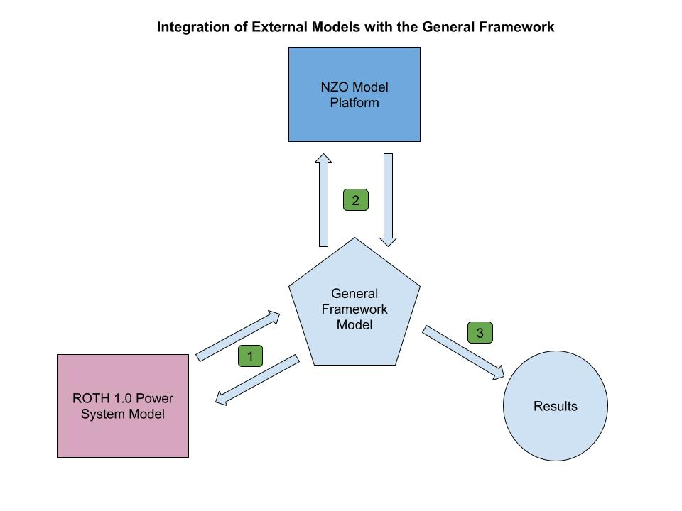
Figure 3 - Integration of External Models with the General Framework

Results

3.1 Hourly system behavior and operational patterns

To establish an operational understanding of the modeled electricity system, this section examines its hourly behavior across representative time slices and over the full planning horizon. Figures 4–6 present the hourly generation mix, storage activity, and demand coverage under different temporal perspectives, highlighting how system dynamics evolve across seasons and over time.

Figure 4 shows the hourly generation mix during a representative winter week in January 2050. During this period, solar generation is relatively moderate, with shorter daylight hours and lower peak output. As a result, gas-fired generation plays a dominant balancing role, particularly during evening and nighttime hours when solar production is unavailable. Battery discharge contributes primarily during peak demand hours, while charging activity remains limited due to reduced solar surplus. Curtailment is minimal in this period, reflecting the closer alignment between generation and demand under winter conditions.
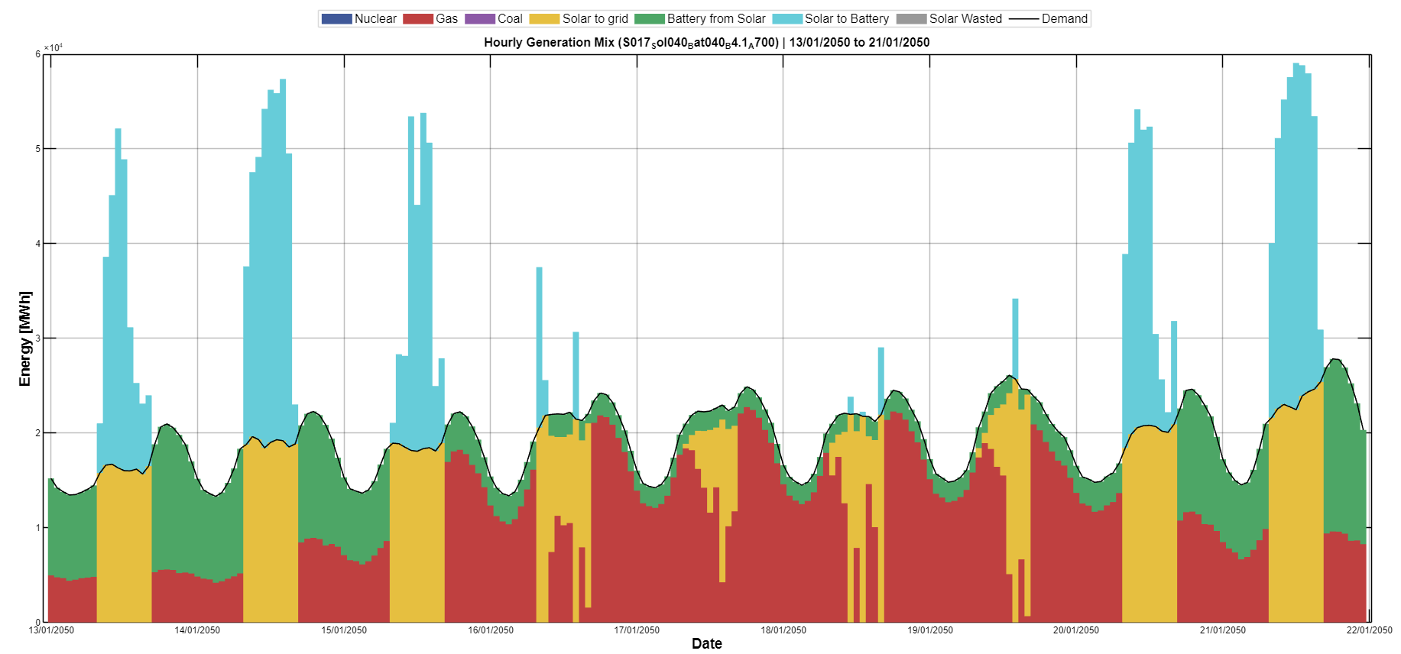
Figure 4 - Generation mix, hourly resolution, winter week (January 2050)
In contrast, Figure 5 illustrates the system's behavior during a representative summer week in June 2050. Solar generation reaches significantly higher levels, driven by longer daylight hours and higher capacity factors. This leads to pronounced midday surpluses, which are partially absorbed through battery charging. Battery discharge becomes a central mechanism for shifting solar energy from midday to evening and from one day to another. Despite this flexibility, visible levels of solar curtailment emerge during peak production hours, indicating that storage capacity and demand-side absorption are insufficient to fully utilize all available solar output. Gas generation is substantially reduced during daylight hours and is primarily dispatched during nighttime and residual balancing periods.
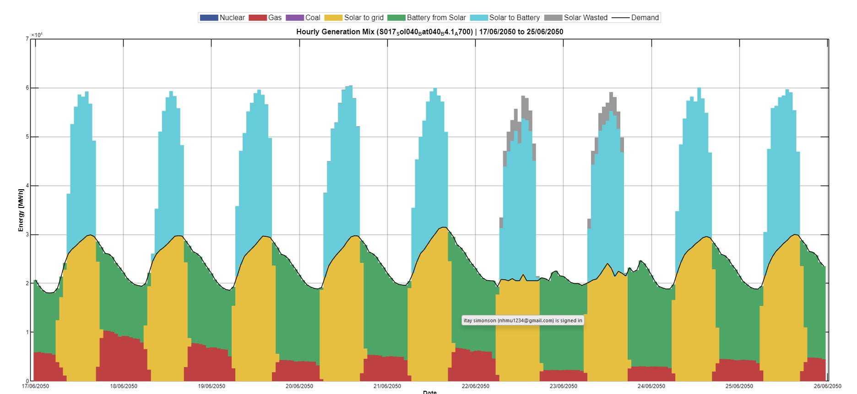
Figure 5 - Generation mix, hourly resolution, summer week (June 2050)
Figure 6 presents the hourly generation mix for a representative year (2050), illustrating system operation over approximately 8760-time steps under a high-renewable configuration. The figure highlights the dominant role of solar generation during daytime hours, alongside pronounced daily and seasonal variability. Battery activity emerges as a central balancing mechanism, charging primarily during periods of high solar output and discharging during evening and night hours when solar generation declines. Gas-fired generation persists as a residual dispatchable resource, contributing mainly during periods of low renewable availability and increased demand. Seasonal patterns are clearly visible, with extended summer periods characterized by sustained solar surpluses and increased levels of curtailment, and winter periods showing greater reliance on dispatchable generation and storage discharge. Importantly, the figure demonstrates that high renewable penetration does not eliminate temporal variability in the system. Instead, variability is redistributed across technologies, with storage and curtailment becoming integral components of system balancing rather than marginal features.
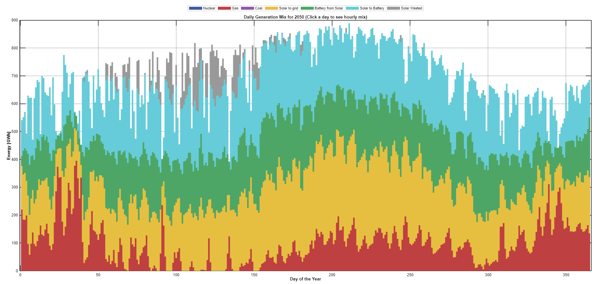
Figure 6 Generation mix in hourly resolution 2050 80 RE%
Taken together, the hourly results demonstrate that high renewable penetration fundamentally reshapes system operation rather than smoothing it. Temporal mismatches between generation and demand remain a defining feature, particularly under high solar deployment. Battery storage mitigates these mismatches by reallocating energy across hours yet cannot fully eliminate surplus generation during peak solar periods. These operational patterns provide essential context for the system-level relationships between land use, cost, renewable penetration, and emissions examined in the following sections.

3.2 System feasibility space: land, cost and renewable penetration

This section examines the relationship between renewable penetration in 2050 and the two system-level constraints that define the feasible solution space: total system cost and available solar land. Figure 7 presents a three-dimensional mesh illustrating the renewable share in 2050 as a function of the maximum allowable system cost and the upper bound on solar land deployment. A numerical table of Figure 7 is found in the appendices.

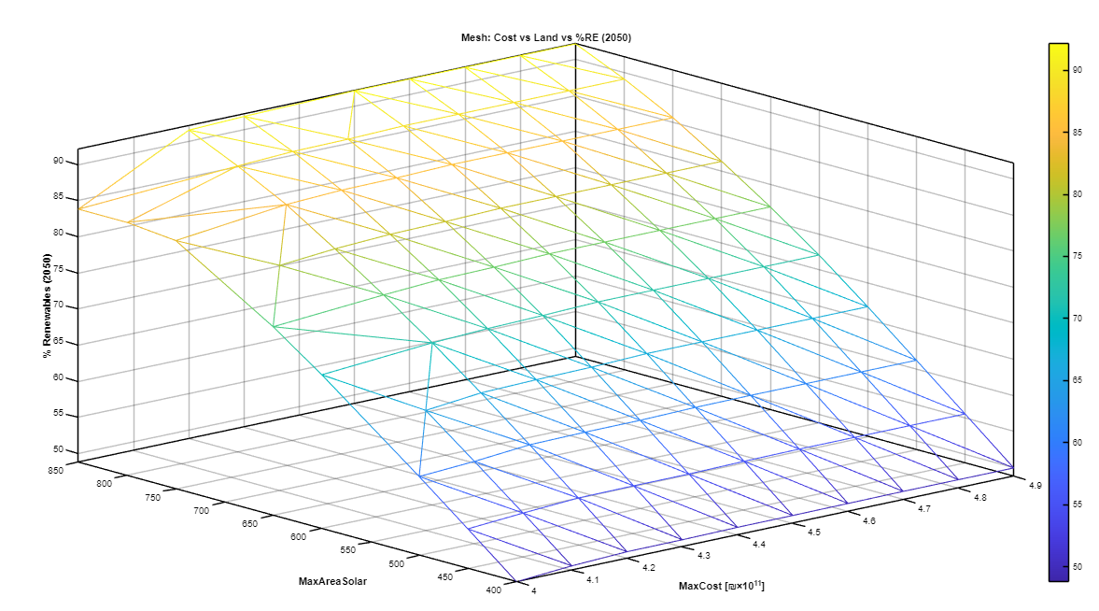
Figure 7a - Feasible renewable penetration in 2050 as a function of system cost and solar land availability (3D mesh)
The surface reveals a clear joint dependency between cost and land availability. Renewable penetration increases as either constraint is relaxed, but only within a bounded region. Moderate renewable shares can be achieved under relatively conservative assumptions on both cost and land. However, as penetration approaches higher levels, the surface flattens and then steepens sharply, indicating diminishing returns from relaxing constraint in isolation.

Importantly, the figure shows that increasing the system cost alone does not yield substantial gains in renewable penetration once land availability becomes restrictive. Similarly, expanding solar land without sufficient budgetary flexibility produces only limited improvements. High renewable shares are attainable only when both constraints are simultaneously relaxed, highlighting the coupled nature of economic and spatial feasibility.

The geometry of the surface further suggests the existence of a saturation region. Beyond a certain threshold, additional increases in cost or land translate into marginal changes in renewable penetration. This behavior reflects structural limits imposed by the temporal alignment of generation and demand, as well as by the balancing capabilities of the system. As a result, the feasible solution space is not continuous but exhibits regions of rapid transition separated by broad plateaus.

To complement the feasibility perspective defined above, Figure 8 presents the total cumulative emissions over the full modeling horizon for all scenarios, disaggregated by generation source. While Figure 7 characterizes which renewable shares are technically and economically attainable, this emissions view highlights the environmental implications across the feasible solution space. The results show a pronounced decline in cumulative emissions as renewable penetration increases, driven primarily by reduced reliance on gas-fired generation. However, the transition is not uniform: large portions of the feasible space are associated with relatively similar emissions levels, followed by sharper reductions only at higher renewable shares. This pattern mirrors the plateau structure observed in the feasibility surface and underscores that not all feasible configurations deliver comparable emissions outcomes.
The surface in Figure 7a reveals a clear joint dependency between system cost and land availability. Renewable penetration increases as either constraint is relaxed, but only within a bounded region. Moderate renewable shares can be achieved under relatively conservative assumptions on both cost and land. However, as penetration approaches higher levels, the surface gradually flattens into a plateau, indicating diminishing marginal returns.
Importantly, the figure highlights the coupled nature of economic and spatial constraints. For land availability constraints below approximately 750 km², the surface becomes nearly horizontal along the cost axis. This indicates that without sufficient land for solar expansion, allocating additional budget to the system yields virtually no increase in the renewable energy share achieved by 2050. Conversely, when land is no longer the primary bottleneck, even modest capital investments drive a steep ascent in renewable penetration. High renewable shares are therefore attainable only when both economic and spatial constraints are simultaneously resolved.
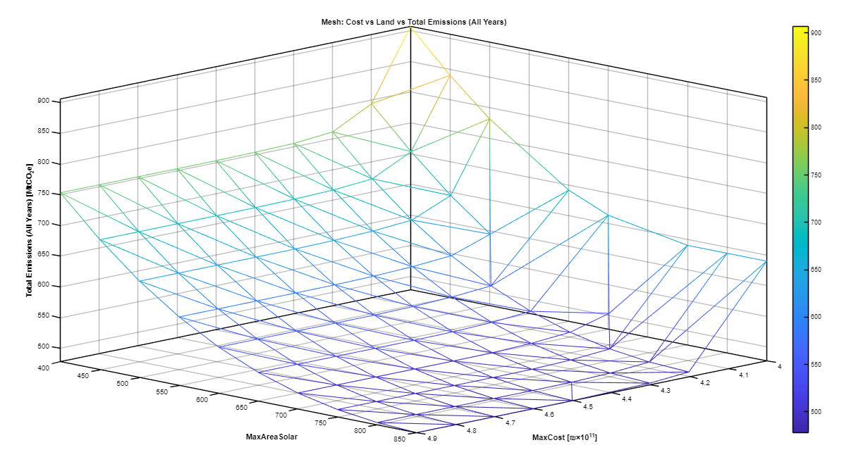
Figure 7b - Total cumulative emissions (all years) as a function of maximum system cost and solar land availability (3D mesh).

While Figure 7a focuses on the renewable share in the target year of 2050, Figure 7b illustrates the corresponding impact on total cumulative emissions across the entire modeling horizon (2023–2050). The contrast between the two surfaces provides a critical operational insight regarding the timing of infrastructure investments. Although increasing the budget under constrained land scenarios fails to improve the 2050 renewable share, it profoundly reduces total cumulative emissions. This occurs because increased capital availability allows the optimization solver to accelerate the construction of renewable and storage infrastructure—subject to ramping limits—earlier in the planning horizon. This expedited transition displaces fossil-fired generation in the intermediate decades, thereby averting millions of tons of carbon dioxide equivalent over the system's lifetime, even if the end-state configuration remains constrained by land.
Furthermore, Figure 7b reveals a distinct economic saturation threshold. As the maximum system cost constraint is relaxed, total emissions drop precipitously (forming a steep cliff), but this reduction abruptly halts as the budget approaches approximately 4.2–4.3 × 10¹¹ NIS. Beyond this investment threshold, the surface transitions into a wide, flat plateau. At this point, the system is fully saturated; it either exhausts the maximum allotted land or hits absolute physical build-rate constraints. Consequently, any further capital injected into the system provides zero marginal benefit in terms of emissions mitigation. This underscores a fundamental policy constraint: beyond a specific investment threshold, financial resources cannot substitute for the alleviation of physical and spatial bottlenecks.

Overall, Figure 7 defines the outer envelope within which all modeled scenarios operate. It provides a system-level perspective on feasibility, framing renewable penetration not as a linear function of investment or land expansion, but as an outcome emerging from their interaction. The following sections examine how this feasibility space manifests in correlations between system indicators and in the internal composition of generation, storage, and costs.

3.3 Statistical relationships between key system indicators

This section examines the statistical relationships between key system indicators across the full set of modeled scenarios, to characterize the internal structure of the solution space explored by the optimization model. Figure 9 presents a Pearson correlation matrix capturing linear associations between renewable penetration, system cost, solar land use, installed capacities, curtailment, and emissions-related indicators for all 102 scenarios. 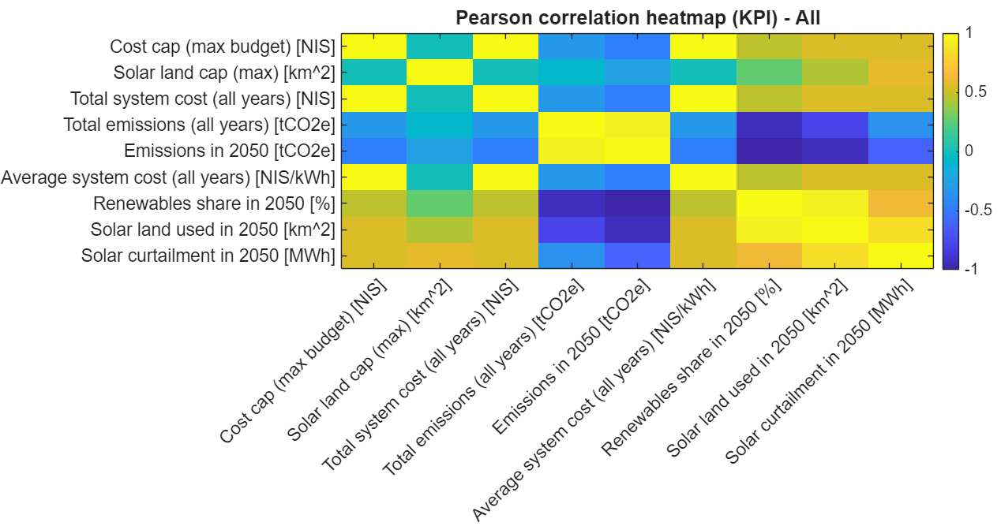
Figure 9 - Pearson correlation matrix across all 101 modeled scenarios
Several dominant relationships emerge from the correlation structure. Renewable penetration in 2050 exhibits a strong positive correlation with solar land use and installed battery capacity, indicating that higher renewable shares are systematically associated with larger spatial footprints and expanded storage infrastructure. At the same time, renewable penetration is strongly negatively correlated with gas generation and emissions, reflecting the progressive displacement of fossil-based electricity generation as renewables expand.

System cost shows a pronounced positive correlation with both solar land use and battery capacity, suggesting that economic and spatial requirements scale together across the full feasible space. Curtailment is also positively correlated with renewable penetration and solar capacity, highlighting that surplus generation becomes increasingly prevalent as solar deployment grows. Battery capacity is correlated with curtailment as well, though less strongly, indicating that storage mitigates but does not fully eliminate excess generation across the range of feasible configurations.

Other relationships appear weaker or more diffuse, suggesting that not all system indicators act as primary drivers of system outcomes. Overall, the correlation analysis reveals that a small number of tightly coupled variables - notably solar land use, battery deployment, and renewable penetration - dominate the structure of the modeled solution space, while other indicators adjust in response to these core dimensions.

Taken together, Figure 9 provides a compact statistical overview of how key system variables co-evolve across the full set of feasible scenarios. This analysis complements the system-level feasibility perspective introduced in Section 3.2 and establishes a baseline against which the effects of subsequent scenario selection and economic filtering will be examined in the following sections.

3.4 Energy balance and demand coverage in 2050
This section examines how electricity demand in 2050 is met across the full set of modeled scenarios, focusing on the composition of annual energy supply and the role of different technologies in covering demand. Figure 10 presents the annual electricity balance in 2050, showing the contributions of solar generation, gas-fired generation, battery discharge, and curtailed energy across all scenarios.

Despite identical demand levels, the figure reveals substantial variation in how demand is supplied. Scenarios with lower renewable penetration rely predominantly on gas generation, with solar contributing a smaller share and storage playing a limited role. Curtailment in these cases is negligible, reflecting the close alignment between generation and demand under fossil-dominated configurations.

As renewable penetration increases, solar generation becomes the dominant source of electricity. This shift is accompanied by a growing contribution from battery discharge, indicating the increasing importance of storage in redistributing solar energy across time. At the same time, curtailed solar energy emerges as a significant component in high-renewable scenarios, reflecting the structural surplus generated during periods of high solar output that cannot be fully absorbed by demand or storage.

The figure also illustrates that increases in renewable penetration do not translate into proportional reductions in dispatchable generation. Gas-fired generation remains present across most scenarios, albeit at declining levels, serving as a residual balancing source during periods when solar and storage are insufficient. This highlights that even under high renewable shares, demand coverage relies on a combination of variable generation, storage, and dispatchable capacity.
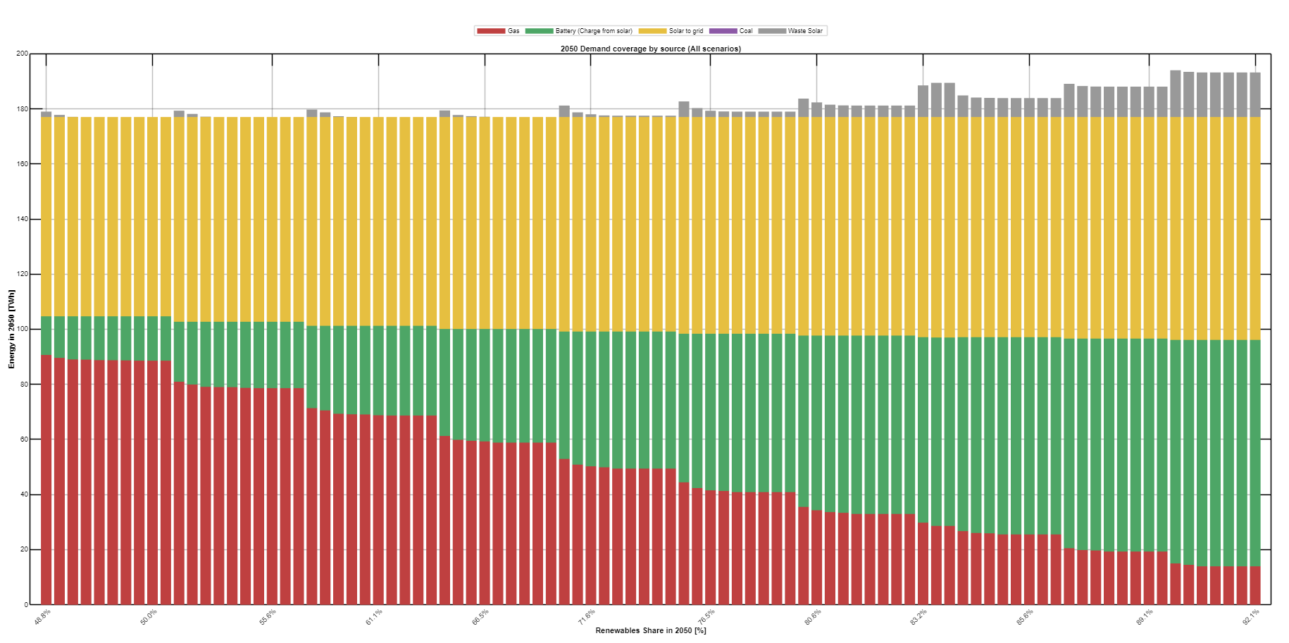
Figure 10 - Annual electricity demand coverage and generation mix in 2050 across all scenarios
A notable exception is the nuclear scenario, in which a constant baseload contribution replaces a substantial share of gas-fired generation. In this configuration, nuclear power provides a stable, low-emission supply that reduces reliance on both gas dispatch and storage cycling, while maintaining full demand coverage. This illustrates that firm low-carbon generation can partially substitute for flexibility resources, albeit under markedly different infrastructural and policy assumptions.

Overall, Figure 10 shows that meeting electricity demand in 2050 involves a reconfiguration of the supply mix rather than a simple substitution of technologies. Higher renewable penetration is associated with increased solar deployment, expanded storage utilization, and rising curtailment, while dispatchable generation continues to play a complementary role. These aggregate energy balance outcomes provide the basis for examining the corresponding infrastructure requirements and capacity levels in the following section.

3.5 Cost efficiency and system cost structure in 2050 – selected scenarios

Following the characterization of the full feasible solution space, the analysis now narrows its focus to a subset of scenarios selected based on economic efficiency. This subsection introduces the cost-based filtering criterion and examines the system cost structure of the selected scenarios in 2050.

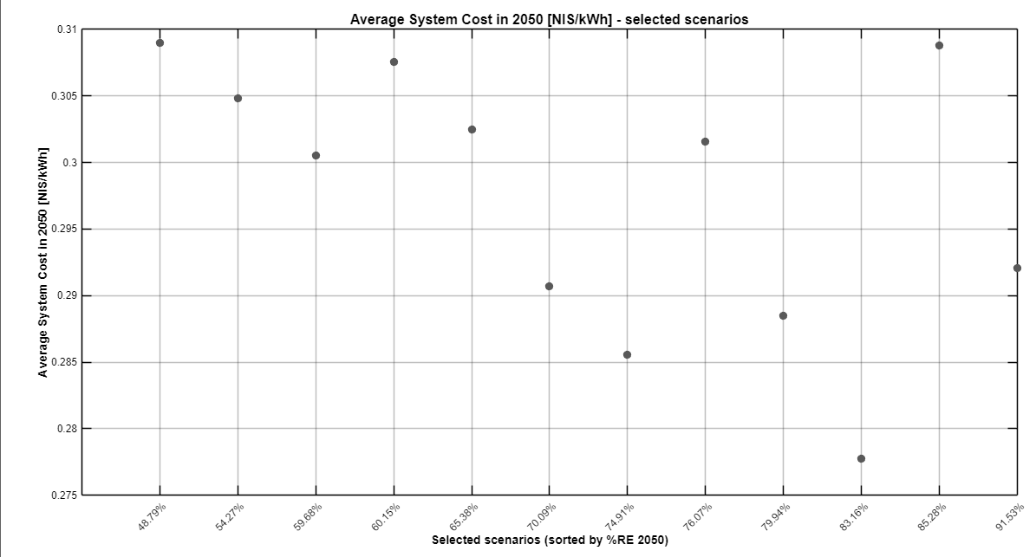
Figure 11a - Average Direct System Cost (LCOE) in 2050
Figure 11 presents the average system cost in 2050 for the 13 scenarios selected for further analysis. These scenarios represent the most cost-efficient configurations within their respective renewable penetration ranges and are therefore treated as economically plausible system designs. By construction, the selected scenarios span a wide range of renewable shares while excluding configurations characterized by extreme infrastructure expansion or inefficient surplus generation. The figure reveals a clear and monotonic increase in average system cost as the renewable share rises. Scenarios with moderate renewable penetration achieve the lowest electricity costs, while progressively higher renewable fractions are associated with higher average system cost values. While high-renewable scenarios exhibit higher average system cost than the fossil-dominated configuration, the cost premium increases gradually rather than abruptly. This pattern indicates that deep decarbonization is associated with a bounded and continuous increase in electricity costs rather than a sharp economic discontinuity.

Importantly, the figure also allows for a direct comparison between high-renewable scenarios and the fossil-dominated configuration. The results show that scenarios with very high renewable shares incur higher average system cost than the fossil-based case, indicating a cost premium associated with deep decarbonization. However, this premium remains bounded and increases gradually rather than abruptly, suggesting that substantial emissions reductions can be achieved without a disproportionate escalation in electricity costs
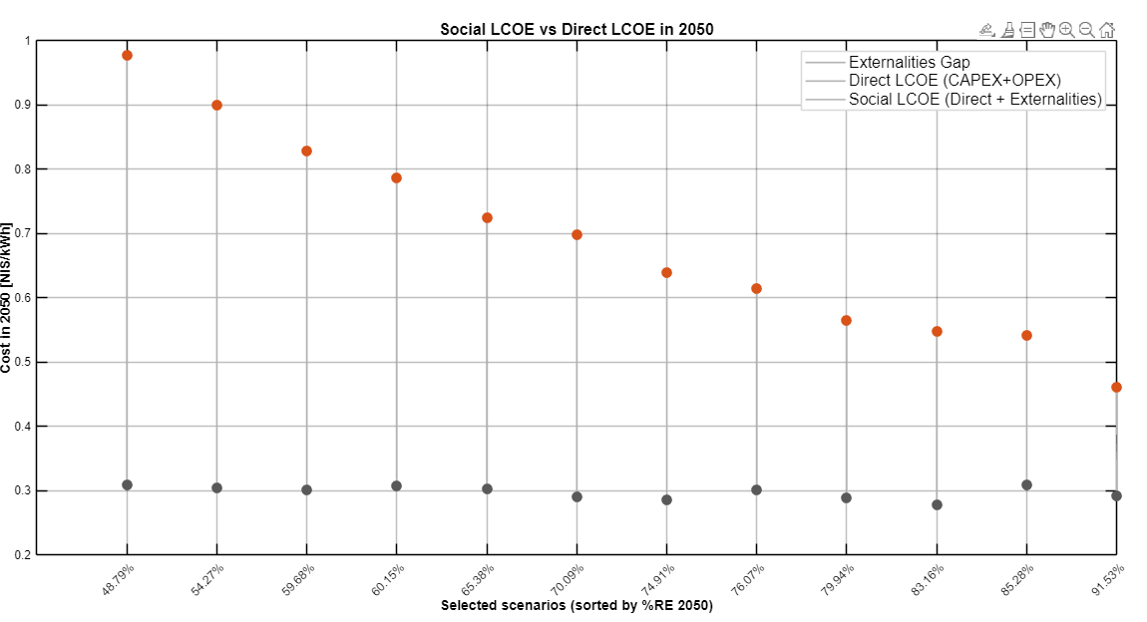
Figure 11b - Social LCOE vs Direct LCOE in 2050
.

Figure 11a presents the average direct system cost (LCOE) in 2050 for the selected cost-efficient scenarios. Expanding the analysis across a broader spectrum of renewable penetration reveals a distinct U-shaped cost curve, challenging the assumption that decarbonization inherently increases electricity prices. As the renewable share increases from approximately 48% to 83%, the average direct cost per kWh steadily declines. In this range, the integration of zero-marginal-cost solar and battery storage effectively displaces expensive fossil fuel operational expenditures (OPEX) without incurring severe curtailment penalties. The direct LCOE reaches a minimum economic 'sweet spot' around 83% renewable penetration. However, pushing the system beyond this threshold toward deeper decarbonization (approaching 92%) reverses this trend. Achieving these very high renewable shares requires disproportionate capital investments in redundant solar capacity and large-scale seasonal storage to bridge prolonged periods of low generation, thereby driving the direct engineering costs back up.
To provide a comprehensive macroeconomic perspective, Figure 11b compares this Direct LCOE with the Social LCOE, which explicitly internalizes the external costs of greenhouse gas emissions, air pollution, and end-of-life infrastructure provisions. This comparison fundamentally alters the economic narrative. In fossil-dominated scenarios (e.g., ~48% renewable penetration), the gap between direct and social costs is vast; the true cost to the national economy is overwhelmingly dominated by unpriced externalities. As renewable deployment scales, this externalities gap shrinks dramatically. Consequently, the Social LCOE exhibits a steep and monotonic decline across the entire spectrum. This demonstrates that while very high renewable configurations (above 85%) may impose a structural cost premium on the direct power system budget due to storage redundancy, they conclusively remain the most economically efficient choice for the national economy when environmental damages are accurately accounted for.

To better understand the drivers underlying these cost outcomes, Figure 12 presents the annual system cost in 2050 decomposed into capital expenditures (CAPEX), operational expenditures (OPEX), and external costs by technology for the selected scenarios. While CAPEX and OPEX are incorporated within the optimization through the cumulative budget constraint, the objective function itself minimizes emissions rather than total cost. The external cost component shown here is evaluated ex-post based on the optimized capacities and dispatch outcomes,
These monetized externalities therefore provide an additional comparative lens rather than influencing the optimization results. The figures show that total system cost increases systematically with renewable penetration, and that this increase is primarily driven by capital investments rather than operating costs. Solar and battery technologies account for most system expenditures across all selected scenarios, with CAPEX constituting the dominant component as renewable penetration rises.
providing an additional comparative lens.
Crucially, the expanded spectrum of scenarios contradicts the assumption that higher renewable penetration inherently inflates the total socioeconomic burden. When accounting for externalities, the total annual system cost decreases systematically as renewable penetration rises, driven by a massive reduction in climate and air pollution damages (the dark grey component). Focusing strictly on direct system costs (the colored components), the figure illustrates a fundamental structural shift in the power sector's economy rather than a simple cost escalation. At lower renewable shares (e.g., ~48%), the system is OPEX-dominated, relying heavily on continuous operational expenditures for fossil fuel combustion. As renewable penetration increases, these operational costs are progressively replaced by upfront capital investments. In the highest renewable scenarios, solar and battery CAPEX constitute the dominant direct system expenditures. This confirms that deep decarbonization transforms the electricity grid from a high-OPEX, high-externality model into a CAPEX-intensive, low-externality infrastructure, keeping direct annual costs relatively stable while drastically reducing the overall cost to society.

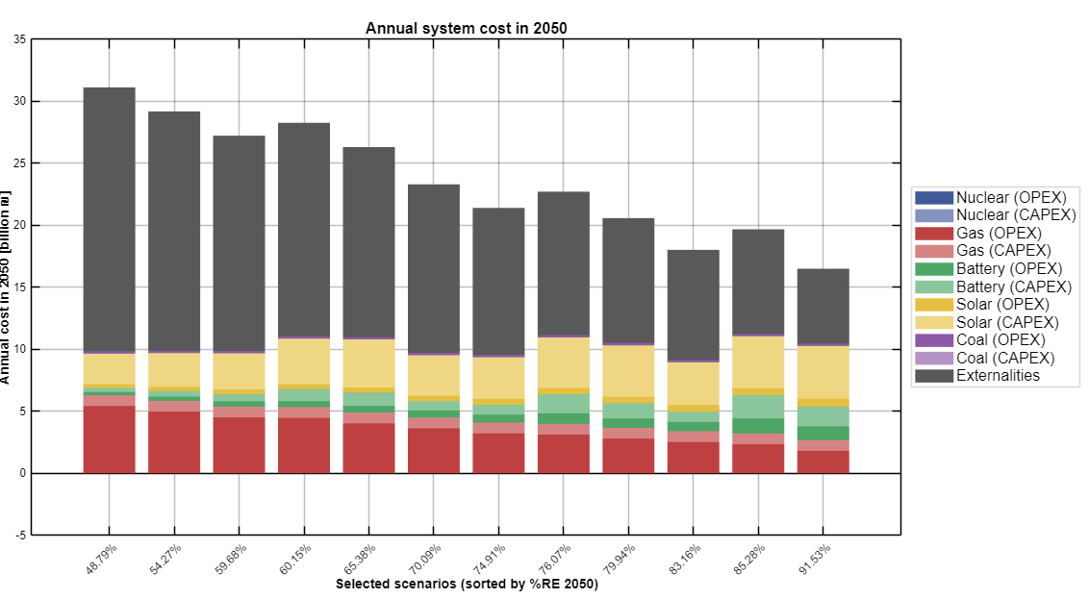
Figure 12 - Annual system cost in 2050 decomposed by source (OPEX + CAPEX + externalities) for the selected
In contrast, the fossil-dominated configuration (e.g., the 48.79% scenario) exhibits a markedly different cost structure. While its direct system costs are relatively low due to limited capital investment, a substantial additional cost arises from externalities associated with air pollution and greenhouse gas emissions. These external costs constitute a significant fraction of the total system socioeconomic cost in the fossil-based scenario, indicating that its apparent economic advantage relies on the exclusion of environmental damage. As renewable penetration increases, external costs decline sharply and become negligible in high-renewable scenarios, while total system cost becomes increasingly dominated by upfront infrastructure investments Concurrently, the internal composition of the direct system cost shifts, becoming increasingly dominated by upfront infrastructure investments.

The nuclear scenario, included as a counterfactual case, is intentionally excluded from the average system cost-based selection shown in Figures 11a/b and 12. Its cost structure reflects a fundamentally different system logic, characterized by high upfront capital investment and firm low-carbon baseload generation, rather than by modular expansion of variable renewables and storage. As such, it does not compete directly within the economically efficient solar-based solution space examined here. Instead, the nuclear case serves to illustrate how the availability of firm low-emissions capacity can alter the balance between capital investment, external costs, and flexibility requirements, a point that is further discussed in the policy interpretation section.
Taken together, Figures 11 a/b and 12 establish a clear economic rationale for focusing the remainder of the analysis on the selected scenarios. These configurations represent a compromise between achieving high renewable penetration and maintaining cost efficiency, and they form the basis for the detailed examination of infrastructure scale, land use, and emissions presented in the following sections.

3.6 Emissions in 2050 by source - selected scenarios
This subsection examines the emissions outcomes in the target year 2050 for the selected scenarios, focusing on the composition of emissions by generation source. While the previous section characterized cumulative emissions across the full modeling horizon, the present analysis isolates the end-state emissions profile, which is of direct relevance to net-zero policy targets.

Figure 13 presents greenhouse gas emissions in 2050 disaggregated by source for the selected scenarios, ordered by increasing renewable share. A clear monotonic decline in total emissions is observed as renewable penetration increases. This reduction is driven almost entirely by the displacement of gas-fired generation, which remains the dominant source of emissions across all scenarios in which it is present.
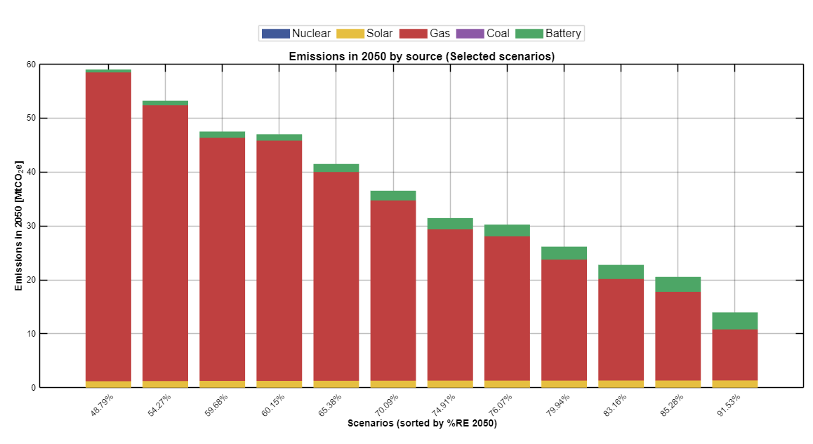
Figure 13- Emissions in 2050 by generation source for the selected scenarios
At moderate renewable shares, residual emissions remain substantial, reflecting the continued role of gas as a balancing resource. As renewable penetration exceeds approximately 90%, emissions in 2050 fall sharply, approaching low levels in the highest-renewable configurations. Emissions from solar and battery technologies remain negligible across all scenarios, underscoring that operational emissions are almost exclusively associated with fossil generation.

Importantly, the figure highlights that scenarios which appear relatively similar in terms of cumulative feasibility can differ markedly in their 2050 emissions profile. This distinction reinforces the importance of examining end-of-year outcomes in addition to long-term averages or cumulative indicators. The results indicate that while intermediate renewable targets deliver meaningful emissions reductions, achieving near-zero emissions in the electricity sector requires pushing renewable penetration into the upper end of the feasible solution space.

3.7 Installed capacities and infrastructure scale in 2050 – selected scenarios

This section examines the generation and storage capacities required in 2050 under the subset of scenarios selected as economically efficient according to their average system cost. By focusing on these selected scenarios, the analysis highlights the characteristic infrastructure scale that emerges when high renewable penetration is pursued under cost-efficiency constraints and clarifies how capacity expansion translates into operational system behavior.
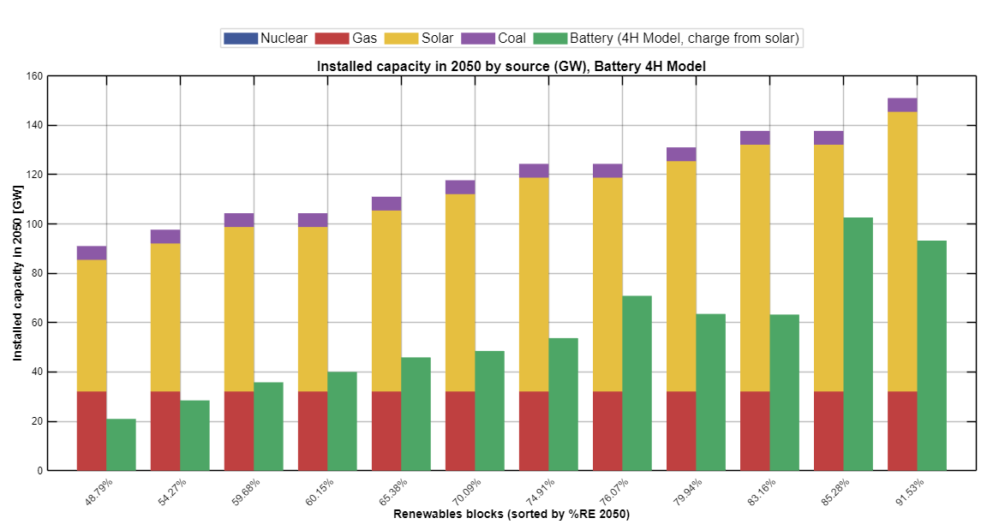
Figure 15 – Installed generation and storage capacities in 2050 across selected scenarios

Figure 15 presents the installed capacities of the main system components in 2050 for the selected scenarios, including solar generation, battery storage, gas-fired capacity, and other dispatchable sources. Compared to the full scenario space discussed earlier, the selected scenarios exhibit a significantly narrower range of installed capacities, indicating a convergence toward infrastructure configurations that balance system performance with economic feasibility.
Across all selected scenarios, solar generation constitutes the largest share of installed capacity, reflecting its central role in meeting electricity demand under high renewable penetration. As the renewable share increases, installed solar capacity grows steadily, but without the extreme expansions observed in some high-renewable configurations that were excluded by the average system cost-based selection. This pattern indicates that economically efficient systems rely on substantial but moderated solar deployment, rather than unbounded capacity expansion.
Battery storage capacity also plays a structural role across the selected scenarios. Installed battery capacity increases systematically with renewable penetration, underscoring the importance of temporal balancing in systems dominated by variable solar generation. However, the growth in storage capacity remains bounded within the economically efficient subset, suggesting that excessive storage expansion is disfavored on cost grounds. This highlights the role of batteries as an enabling and complementary technology, facilitating renewable integration rather than substituting for generation capacity.

To further examine the implications of storage deployment, Figure 16 presents the total battery energy capacity in 2050 for the selected scenarios under the 4-hour storage model. The figure reveals a clear non-linear relationship between renewable penetration and required battery energy capacity. While moderate renewable shares can be supported with relatively limited storage, scenarios exceedingly approximately 90% renewable penetration require sharply higher battery energy capacities. This acceleration reflects the increasing difficulty of balancing residual variability and prolonged low-generation periods as the system approaches very high renewable shares.

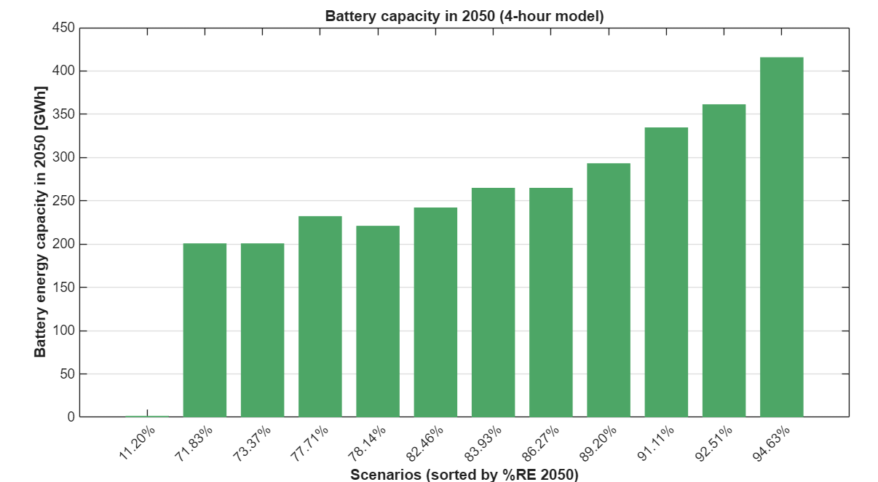
Figure 16 - Battary Capacity 2050 4H model

Beyond installed capacity levels, the operational behavior of battery storage provides additional insight into system dynamics. Figures 17 and 18 illustrate the battery state-of-charge trajectories for a representative high-renewable scenario
(RE ≈ 91%) during the summer and winter period in 2050, respectively. In summer, battery operation is characterized by pronounced daily charge–discharge cycles, with charging during midday solar surpluses and discharging during evening and nighttime demand peaks. These patterns demonstrate that storage primarily functions as an intra-day balancing mechanism, rather than as a means of seasonal energy shifting.
In winter, battery operation exhibits greater variability and longer discharge events. Extended periods of low solar availability led to multi-day depletion episodes, during which the battery approaches low state-of-charge levels. This behavior indicates that even substantial storage capacity cannot fully eliminate temporal mismatches between generation and demand, particularly during prolonged low-renewable periods. Instead, storage mitigates but does not resolve these structural imbalances, reinforcing the continued need for dispatchable backup capacity.
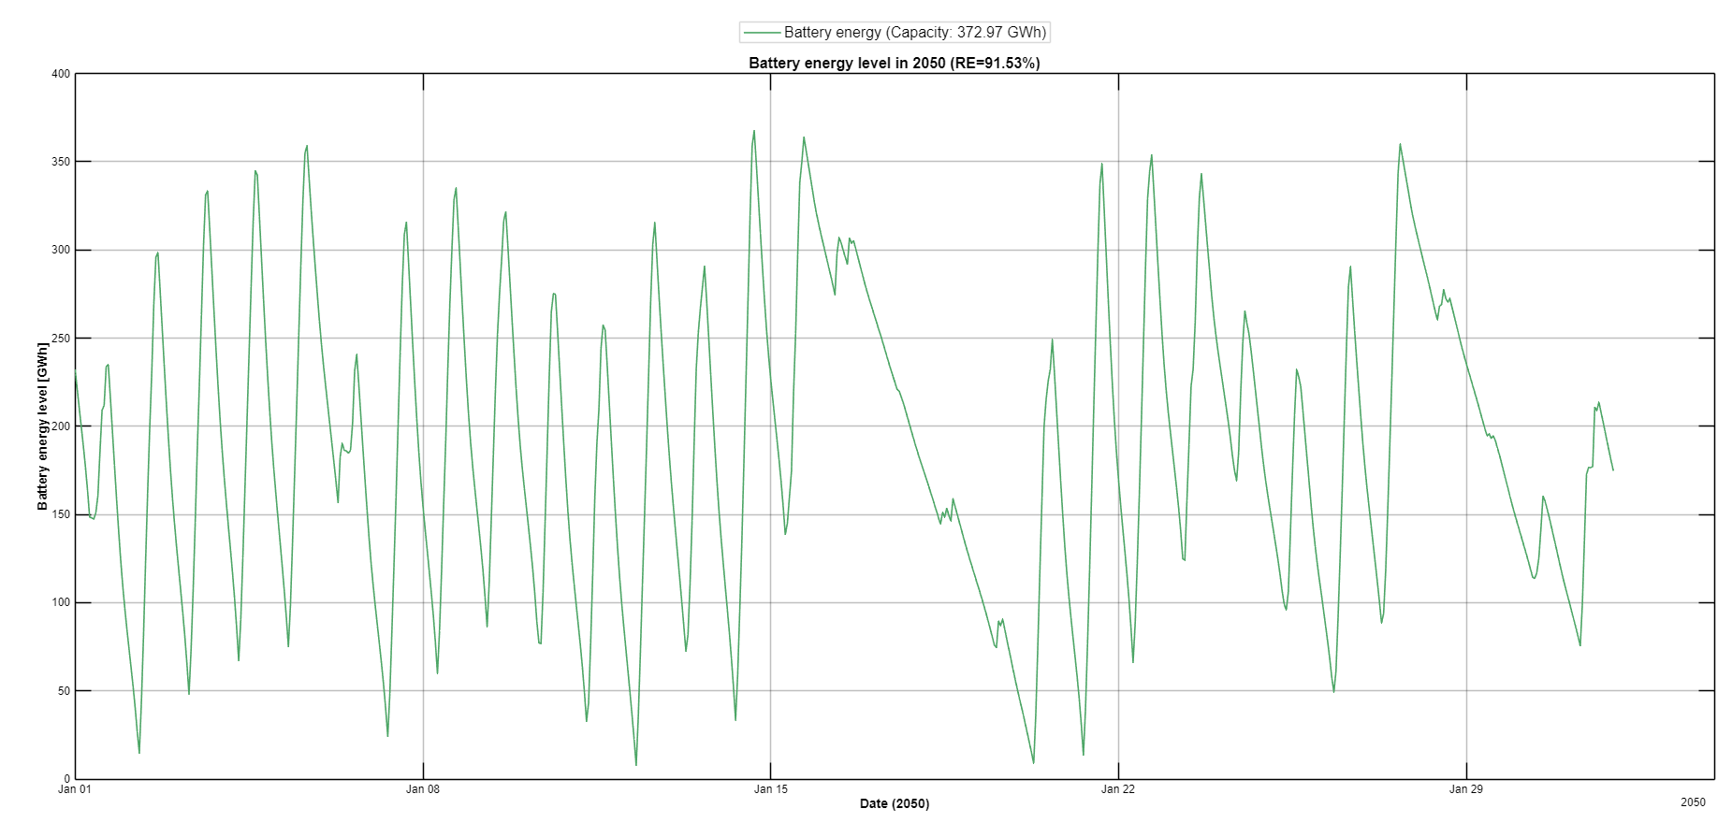
Figure 17 - Battery energy level in winter 2050

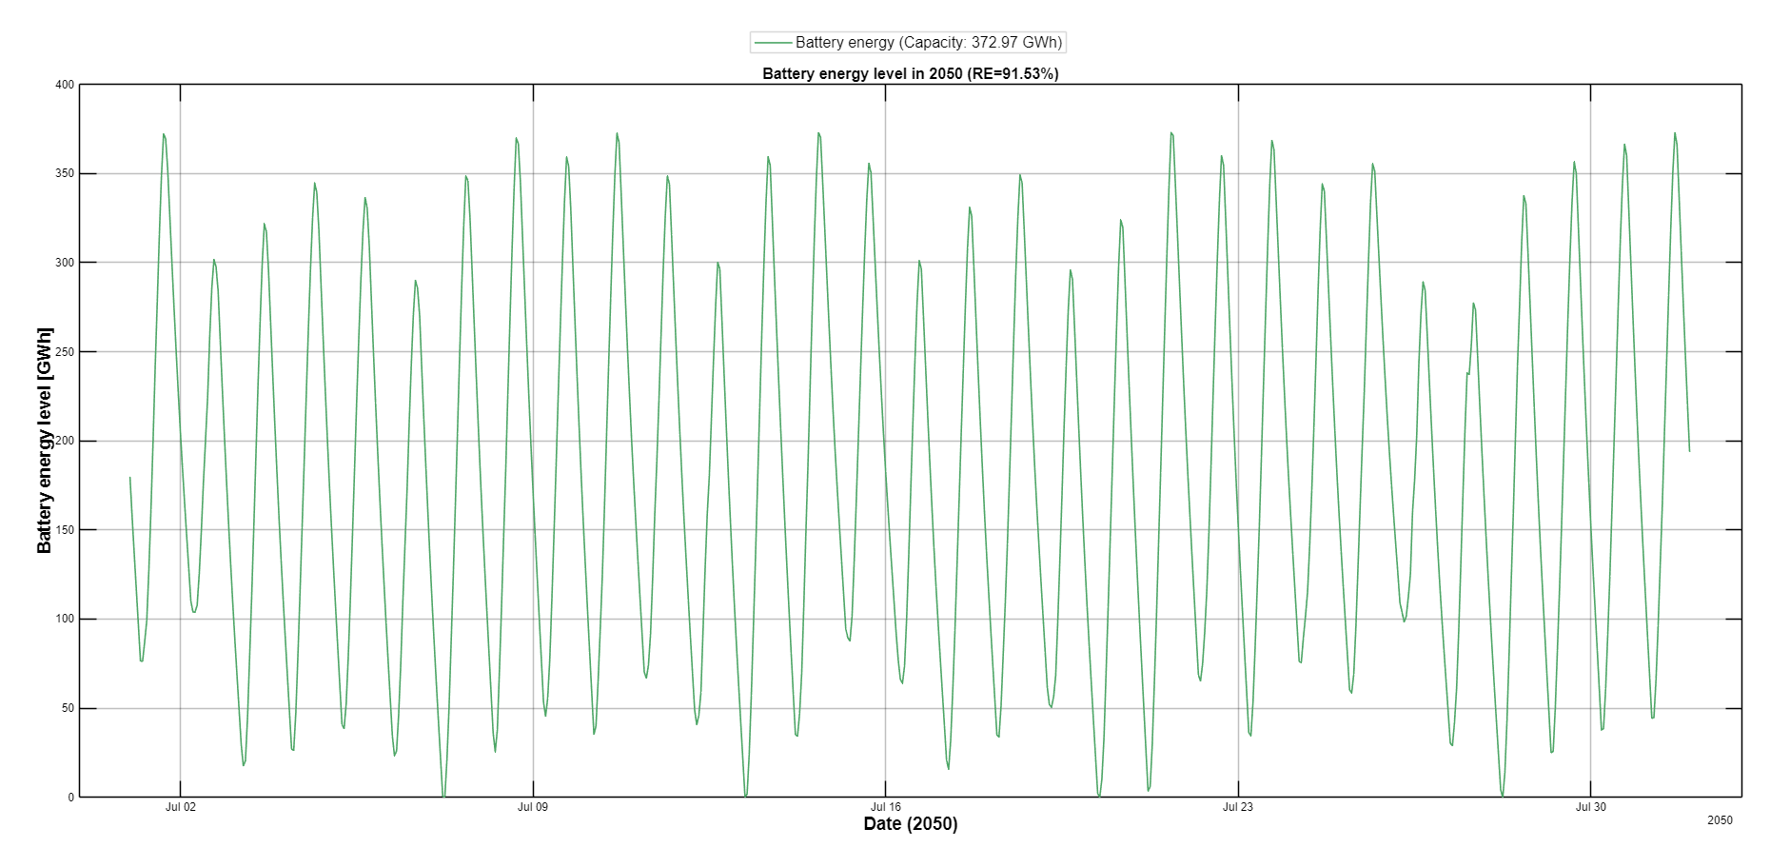
Figure 18 - Battety energy level in winter 2050
These operational insights are quantified in Table 1, which summarizes full-to-empty battery discharge events in 2050 across the selected scenarios. The table shows that as renewable penetration increases, the number of full discharge events does not necessarily rise, but their duration and severity increase. High-renewable scenarios are characterized by fewer but longer discharge events, indicating a concentration of system stress during specific periods rather than frequent cycling. This pattern further underscores the structural role of storage in high-renewable systems and highlights the growing operational demands placed on batteries as renewable shares approach their upper limits.

Gas-fired capacity persists across all selected scenarios, albeit at declining levels as renewable penetration increases.
While the previous figures focus on end-year infrastructure levels, it is also informative to examine how this infrastructure develops over time.
Figure 19 illustrates the temporal evolution of installed capacity for a representative high-renewable scenario. Capacity expansion follows a gradual and cumulative trajectory over the planning horizon, with no abrupt end-of-horizon build-out. Solar and battery deployment increase progressively in alignment with ramping limits and budget constraints. This pattern supports the interpretation that high renewable penetration emerges through incremental structural development rather than discrete late-stage expansion.
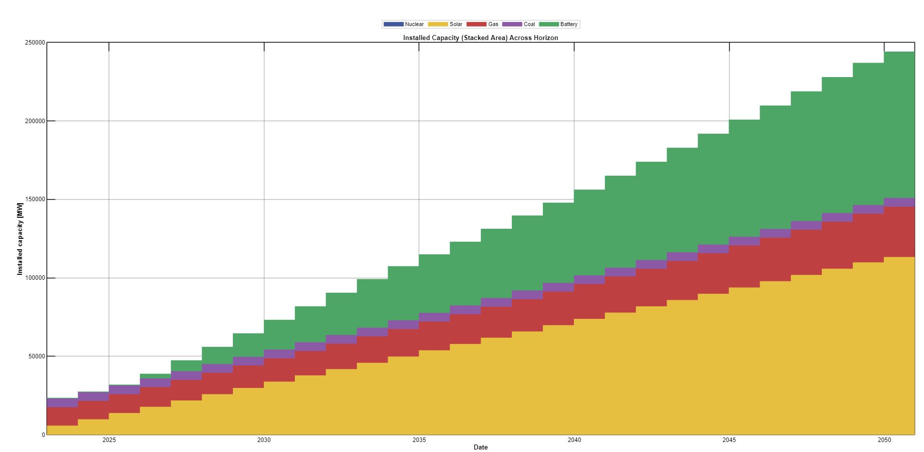
Figure 19 - Installed capacity evolution across the planning horizon for a representative 90 RE% scenario
The continued presence of gas capacity reflects its role as a flexibility and reliability resource rather than a primary energy supplier. Even in scenarios with high renewable shares, dispatchable capacity is retained to address periods of low renewable availability and system stress, emphasizing that decarbonization does not eliminate the need for firm capacity.
RE 2050 | CapBatt 2050 MW | BattEnergy 2050 GWh | Num Events  2050 | Avg hour | Avg day | Med hour | Med day | Max h | Max day
11.20 | 369 | 1.476 | 0 | NaN | NaN | NaN | Na | NaN | NaN
71.83 | 50193.172 | 200.773 | 22 | 343.0 | 14.3 | 157 | 6.6 | 2103 | 88
73.36 | 50193.172 | 200.773 | 46 | 74.4 | 3.1 | 38.0 | 1.6 | 637 | 27
77.71 | 58065.461 | 232.262 | 28 | 210.1 | 8.8 | 62.0 | 2.6 | 1502 | 63
78.13 | 55289.716 | 221.159 | 50 | 102.1 | 4.3 | 38.0 | 1.6 | 999 | 42
82.46 | 60555.183 | 242.221 | 58 | 76.7 | 3.2 | 38.0 | 1.6 | 446 | 19
83.92 | 66232.705 | 264.931 | 15 | 526.1 | 21.9 | 253 | 10 | 2630 | 110
86.27 | 66231.449 | 264.926 | 50 | 100.1 | 4.2 | 49.5 | 2.1 | 1256 | 52
89.19 | 73345.126 | 293.381 | 29 | 137.9 | 5.7 | 110 | 4.6 | 872 | 36
91.11 | 83696.970 | 334.788 | 24 | 128.2 | 5.3 | 86.5 | 3.6 | 857 | 36
92.51 | 90369.000 | 361.476 | 13 | 171.6 | 7.2 | 88.0 | 3.7 | 833 | 35
94.62 | 103953.902 | 415.816 | 3 | 591.3 | 24.6 | 497 | 20 | 1166 | 49
Table 1 - Battery discharge event statistics in 2050 across selected scenarios
The nuclear scenario, included as a sensitivity and counterfactual case, exhibits a qualitatively different infrastructure profile. The presence of firm low-carbon baseload capacity substantially reduces the required scale of both solar deployment and battery storage, while also lowering reliance on gas-fired flexibility. This configuration illustrates how the availability of dispatchable low-emissions generation can alleviate some of the infrastructure, land, and storage pressures observed in solar-dominated pathways. Importantly, the nuclear case does not represent an optimized outcome within the selected scenario set but rather serves to highlight how technology availability and policy exclusions fundamentally reshape infrastructure requirements.

Overall, this section demonstrates that cost-efficient pathways to high renewable penetration are associated with a characteristic infrastructure scale defined by large but bounded solar deployment, rapidly increasing but operationally constrained storage capacity, and a residual level of dispatchable generation. Economic filtering constrains the magnitude of infrastructure expansion without altering its fundamental composition, while operational analysis reveals the limits of storage as a sole balancing solution. The gradual build-out trajectory observed over the planning horizon further confirms that infrastructure expansion is progressive rather than concentrated toward the end of the model horizon. These findings provide essential context for understanding the spatial and land-use constraints examined in the following section.

3.8 Refined statistical relationships in the average system cost selected solution space

This subsection concludes the results chapter by examining the statistical relationships between key system indicators within the reduced solution space defined by the average system cost-based scenario selection. While earlier analyses explored correlations across the full set of feasible scenarios, the focus here is on understanding which relationships persist after imposing economic efficiency constraints.
Figure 20 presents a Pearson correlation heatmap calculated solely for the 13 scenarios selected based on their average system cost performance. By construction, this reduced set represents economically efficient system configurations, allowing the analysis to assess whether the structural relationships observed in the full scenario space remain valid once cost considerations are applied.
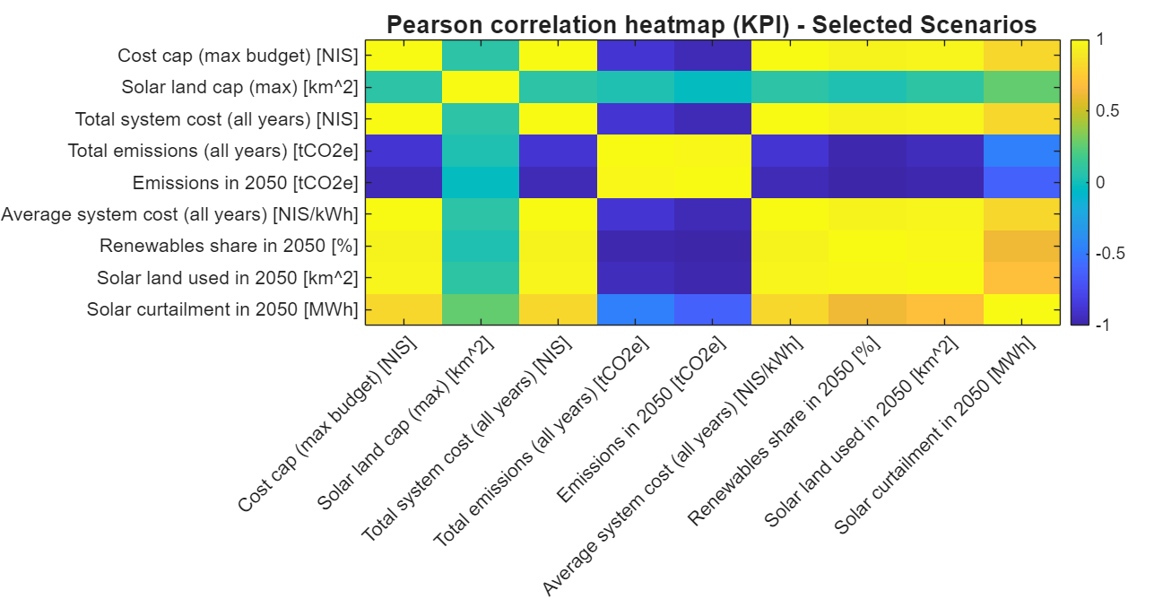
Figure 20 - Pearson correlation matrix across 13 selected scenarios
The correlation structure within the selected scenarios largely preserves the dominant relationships identified previously. Renewable share in 2050 remains strongly and positively correlated with solar land use and curtailment, and strongly negatively correlated with both total emissions and emissions in 2050. These results indicate that the fundamental trade-offs between renewable penetration, land requirements, and emissions reduction are robust to economic filtering and are not artifacts of extreme or inefficient solutions.

At the same time, several correlations involving system constraints and cost-related variables become weaker within the selected subset. In particular, the relationship between renewable share and budget-related indicators is reduced, reflecting the fact that the average system cost-based selection excludes scenarios with excessive capital expansion. As a result, the remaining scenarios exhibit a narrower cost range, within which variations in renewable penetration are driven more by structural system characteristics than by budget limits alone.

Figure 20 demonstrates that economic filtering is refined rather than altering the underlying structure of system interactions. The dominant relationships between renewables, land use, curtailment, and emissions remain intact, while secondary correlations associated with extreme configurations are attenuated. This finding reinforces the consistency of the results presented throughout this chapter and provides a coherent transition to the discussion chapter, where the policy and planning implications of these robust relationships are examined.

Discussion

4.1 Land and emissions as joint binding constraints

The results presented in the previous chapter highlight that land availability and emissions constraints act as jointly binding factors in shaping cost-efficient pathways toward high renewable penetration. Rather than operating independent limitations, these two dimensions interact structurally to define the feasible and economically viable solution space.

The three-dimensional relationship between renewable share, system cost, and solar land availability, as illustrated in the mesh analysis, demonstrates that increases in renewable penetration are consistently associated with both rising land requirements and declining emissions. Importantly, this relationship persists even after filtering scenarios based on average system cost, indicating that land use is not merely a byproduct of extreme or inefficient solutions, but a fundamental constraint inherent to renewable-dominated system designs.

From an emissions perspective, the results show a robust and monotonic reduction in both total system emissions and emissions in 2050 as renewable penetration increases. This trend remains strong across the selected scenarios, confirming that high renewable shares are an effective mechanism for decarbonization. However, achieving these emissions reductions requires substantial expansion of solar generation capacity, which in turn translates directly into increased land use. As a result, emissions mitigation and land availability emerge as tightly coupled trade-offs rather than separable objectives.

The infrastructure analysis further reinforces this interaction. As shown by the installed capacity results, solar deployment scales significantly with renewable penetration, while battery storage capacity increases to enable temporal balancing. These infrastructure requirements, although bounded by economic efficiency considerations, nonetheless impose spatial demands that cannot be ignored. Even in cost-optimal configurations, the system relies on large contiguous solar deployments, making land availability a persistent limiting factor.

The cost decomposition analysis provides additional insight into why land constraints remain binding. As renewable penetration increases, system costs become dominated by capital expenditures associated with solar and storage infrastructure. This capital-intensive nature of decarbonization pathways means that expanding land availability does not merely relax a physical constraint, but also directly affects economic feasibility. Conversely, fossil-dominated configurations appear less land-intensive but incur substantial external costs associated with air pollution and greenhouse gas emissions, underscoring the implicit land–emissions trade-off embedded in system design choices.

Taken together, these findings suggest that land and emissions constraints should be considered jointly in long-term power system planning. Policies aimed at deep decarbonization cannot focus exclusively on emissions targets without addressing spatial planning, land-use prioritization, and public acceptance of large-scale renewable infrastructure. Similarly, land-use constraints implicitly shape the achievable emissions reductions under economically efficient system configurations.

This joint constraint perspective provides a unifying framework for interpreting the results of the optimization model and sets the stage for examining the role of economic robustness, policy levers, and planning trade-offs in the following sections.

4.2 Economic efficiency and sensitivity to system constraints

Beyond identifying cost-efficient scenarios under fixed constraints, it is essential to examine the robustness of the obtained solutions with respect to moderate variations in key system limits. In this study, a local sensitivity analysis was conducted around a representative cost-efficient scenario with approximately 91% renewable energy share in 2050, to assess the stability of system performance under changes in budget and land availability constraints.
The emergence of renewable penetration levels around 90 percent should not be interpreted as a universal structural threshold. Rather, this level reflects the interaction between budget limits, land availability, storage parameters, and demand trajectories within the scenario space examined here. In alternative configurations of these constraints, the exact penetration level at which feasibility margins narrow may shift. However, the analysis consistently shows that as renewable penetration approaches very high levels, the system operates within increasingly tighter feasibility bounds. The local sensitivity results presented below confirm that the system response around this range is continuous and constraint-driven rather than indicative of a discrete structural breakpoint.

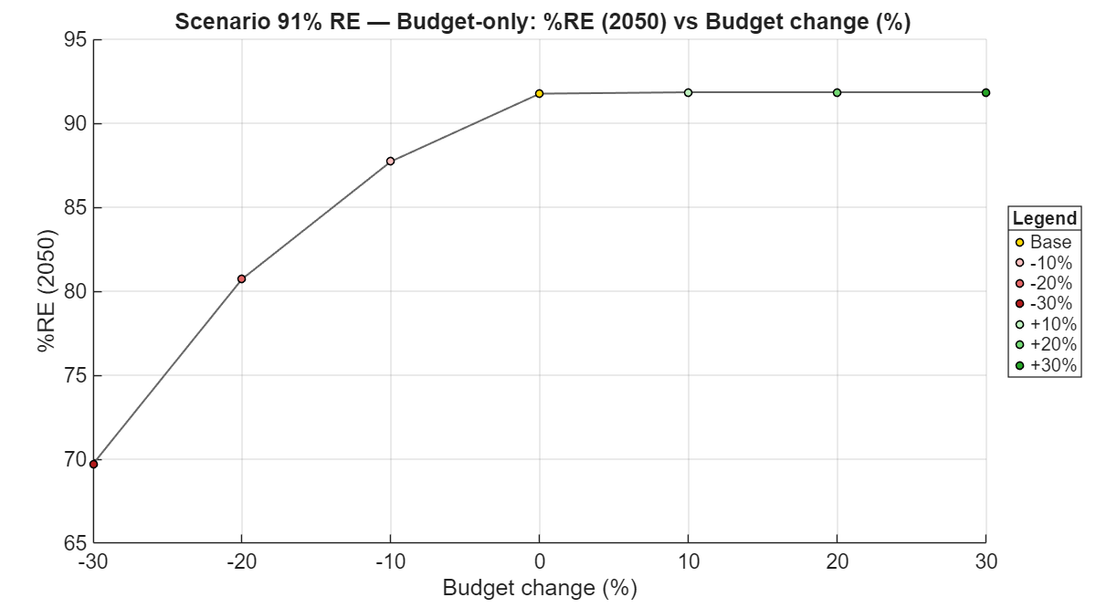
Figure 21 - Budget-only sensitivity of renewable share in 2050 (base scenario)

Figure 21 presents the sensitivity of the renewable energy share in 2050 to changes in the maximum allowable system cost, while holding land availability constant. The results indicate a pronounced asymmetry in system response. Budget reductions of up to 30% lead to a sharp decline in renewable penetration, with the renewable share dropping by more than 20 percentage points relative to the base scenario. In contrast, budget relaxations beyond the base case yield only marginal gains in renewable share, suggesting diminishing returns once a certain investment threshold is reached. This behavior highlights that economic constraints act as a binding limitation primarily on the downside, while additional budget flexibility does not translate linearly into higher renewable penetration.

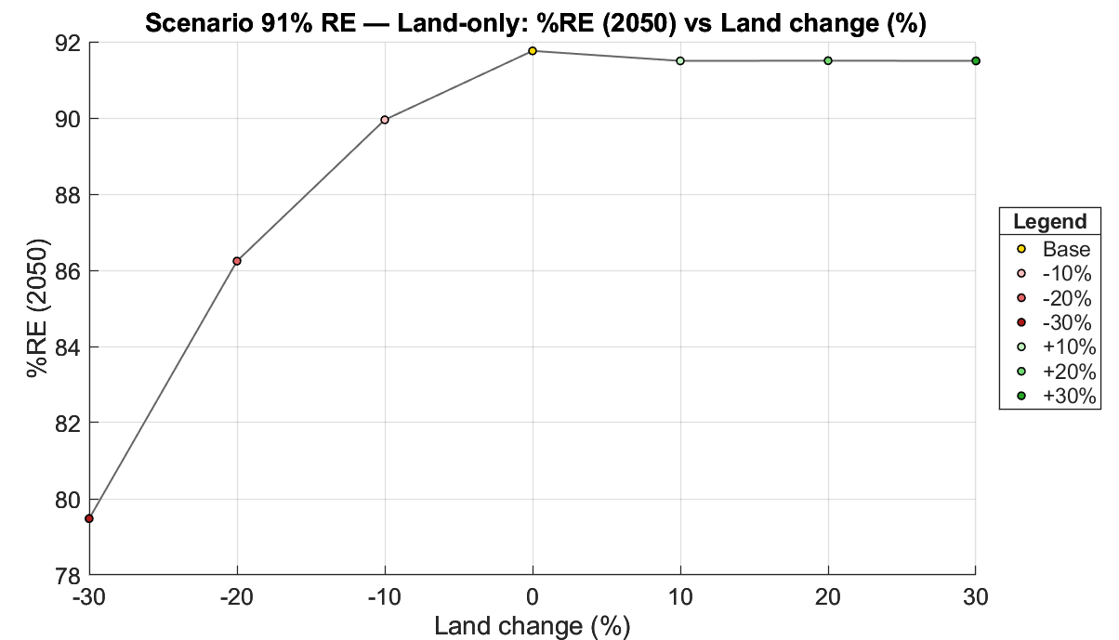
Figure 22 - Land-only sensitivity of renewable share in 2050 (base scenario)

Figure 22 examines an analogous sensitivity analysis with respect to solar land availability, while keeping the budget fixed. A similar qualitative pattern is observed. Reductions in available land significantly constrain renewable deployment, whereas land expansions beyond the base scenario provide limited additional benefits. The saturation of renewable share at high land availability reflects the presence of complementary constraints in the system, such as storage capacity, temporal mismatch between generation and demand, and curtailment effects.

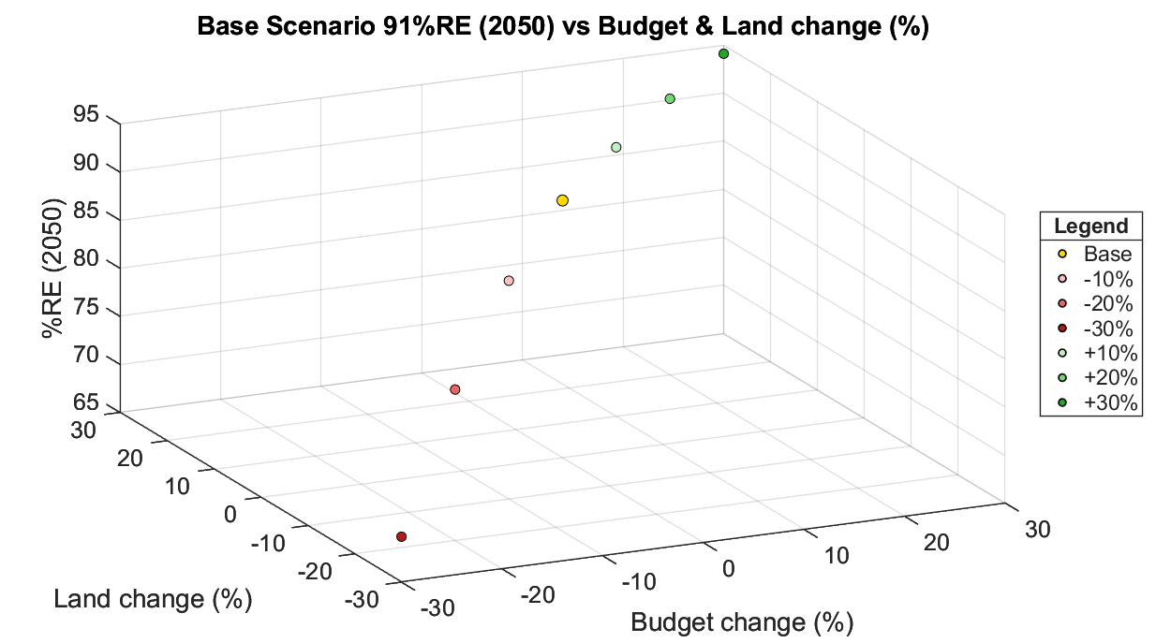
Figure 23 - Joint budget and land sensitivity of renewable share in 2050 (base scenario)

Figure 23 extends this analysis by jointly varying both budget and land constraints. The combined sensitivity surface reveals that high renewable penetration is only achievable within a relatively narrow feasible region, where sufficient financial and spatial resources coexist. Outside this region, the renewable share deteriorates rapidly, particularly when both constraints are tightened simultaneously. Importantly, the results show that relaxing only one constraint is insufficient to compensate for the tightening of the other, underscoring the coupled nature of economic and spatial limitations in high-renewable electricity systems.

Overall, this sensitivity analysis demonstrates that while cost-efficient high-renewable solutions exist, they are locally fragile to adverse changes in key constraints. At the same time, the limited gains obtained from further relaxing, already non-binding constraints reinforce the notion that achieving very high renewable shares requires coordinated policy interventions across multiple dimensions. These findings support the interpretation that system optimality in this context is characterized not only by minimum cost, but also by constrained feasibility and robust considerations.

It should be noted that the sensitivity patterns identified in this section are evaluated around solutions that are optimal under specific and predefined policy and system constraints. As such, the observed robustness and fragility reflect local optimal responses within given parameter settings, rather than global optimality across the full space of possible system designs.

4.3 Policy implications and system-level insights

The results of this study carry several implications for long-term power system planning and energy policy, particularly in contexts aiming for deep decarbonization under economic and spatial constraints. Rather than pointing to a single optimal system configuration, the analysis highlights a set of structural trade-offs that must be addressed through coordinated policy measures.

First, the findings emphasize that cost efficiency alone is an insufficient guiding principle for system-level decision making. While the average system cost based selection identifies economically plausible configurations, the analysis demonstrates that these solutions operate within a relatively narrow envelope of feasibility. Small deteriorations in key constraints, such as available budget or land, can significantly undermine renewable penetration, whereas relaxing already non-binding constraints yields limited additional benefits.

The sensitivity patterns observed across adjacent land and budget levels indicate that changes in renewable penetration near the high-end of the spectrum are gradual rather than discontinuous. This suggests that the apparent concentration of scenarios around specific penetration levels reflects constraint interaction rather than the existence of a sharp systemic tipping point.

In the present formulation, land availability is modeled purely as a physical constraint rather than as a monetized component of system cost. Land use does not enter the objective function nor the cumulative budget constraint and therefore affects system outcomes exclusively through feasibility limits on solar expansion. The influence of land on renewable penetration thus reflects spatial constraints rather than implicit economic valuation.

From a policy perspective, this suggests that ensuring minimum enabling conditions is more critical than pursuing marginal cost reductions once a cost-efficient regime has been reached.
Second, the coupled role of land and budget constraints implies that policy interventions must be multidimensional. The results show that relaxing a single constraint cannot compensate for the tightening of another, particularly at high renewable shares. Policies focused exclusively on financial incentives, without parallel spatial planning and land-use coordination, are therefore unlikely to deliver the intended outcomes. Similarly, allocating land for renewable deployment without ensuring adequate financial and infrastructural support may fail to translate into effective system transformation. Integrated planning across economic, spatial, and regulatory domains emerges as a prerequisite for robust decarbonization pathways.

Third, the comparison between renewable-dominated and fossil-dominated configurations underscores the importance of accounting for external costs in policy design. Although fossil-based systems may appear economically attractive when only direct system costs are considered, a substantial portion of their true cost arises from externalities associated with air pollution and greenhouse gas emissions. The results indicate that once these external costs are acknowledged, the apparent cost advantage of fossil-dominated systems diminishes significantly. This finding reinforces the economic rationale for incorporating emissions pricing or equivalent regulatory mechanisms into long-term planning frameworks.
The nuclear scenario provides an instructive counterfactual for policy interpretation rather than a prescriptive pathway. By introducing firm low-carbon baseload capacity, it reduces the system’s reliance on both fossil balancing and large-scale storage, thereby alleviating some of the land and flexibility pressures observed in high-renewable configurations. This contrast highlights that Israel’s heavy dependence on solar-based decarbonization is not solely a technological choice, but a consequence of structural constraints and policy exclusions. From a policy perspective, the result underscores the importance of recognizing how the absence or presence of firm low-carbon options reshapes the trade-offs between land use, storage deployment, and system cost.
This cost emissions tradeoff is illustrated in Figure 24, which plots the average system cost in 2050 against the corresponding carbon intensity for the selected scenarios. The figure does not introduce new optimization results but provides a view of the relationship between economic efficiency and environmental performance. Fossil-dominated configurations occupy the low-cost but high-carbon corner of space, while high-renewable scenarios cluster at low carbon intensity with a bounded increase in average system cost. Importantly, the trade-off appears continuous, indicating that substantial emissions reductions can be achieved without a sharp escalation in electricity costs. From a policy perspective, this representation reframes decarbonization not as a binary choice between cost and emissions, but as a continuous spectrum of trade-offs with no sharp economic threshold.
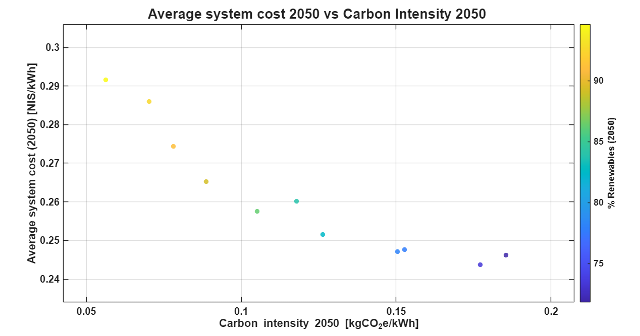
Figure 24 - Average system cost in 2050 versus carbon intensity in 2050 for selected scenarios
Finally, the observed saturation behavior at very high renewable shares carries important implications for target setting. Achieving renewable penetration levels beyond approximately 90% requires disproportionately higher investments and tighter coordination across system components, while yielding diminishing returns in terms of additional emissions reductions. This does not imply that such targets are unattainable or undesirable, but rather that they demand a shift in policy focus from incremental improvements to structural system design, including storage deployment, flexibility resources, and land-use governance.

Overall, the results suggest that successful transition toward a low-emissions electricity system depends less on identifying a single optimal solution and more on maintaining a coherent set of enabling conditions over time. Policies that recognize the joint role of economic efficiency, spatial constraints, and external costs are better positioned to support resilient and effective decarbonization strategies. These insights provide a natural bridge to the final sections of this chapter, which discuss the limitations of the present analysis and outline directions for future research

4.4 Consistency with national-scale electricity planning studies

To further assess the plausibility and relevance of the model outcomes, this section relates the results of the present optimization-based analysis to independent national-scale electricity system studies for 2050. Specifically, the comparison focuses on two recent planning efforts: the Net Zero Outlook (NZO) study and the long-term electricity planning scenarios published by the Israeli Ministry of Energy. These studies differ fundamentally in methodology from the present work, relying on scenario-based planning rather than formal optimization. The purpose of this comparison is therefore not to benchmark model performance, but to examine whether the resulting system characteristics are consistent in scale, structure, and implied trade-offs across independent analytical approaches.

The NZO study provides a particularly relevant reference point, as its projected electricity demand for 2050 is comparable to the demand level assumed in this thesis. Despite methodological differences, both analyses converge on similar structural conclusions. NZO identifies solar photovoltaics as the dominant generation technology, supported by large-scale battery storage to address diurnal and seasonal variability, while maintaining a residual role for dispatchable generation to ensure system reliability. The renewable penetration levels, infrastructure scale, and reliance on storage reported in NZO are well aligned with the cost-efficient high-renewable scenarios identified in this study. This convergence suggests that the system configurations emerging from the optimization model are not artifacts of its formulation but rather reflect robust structural features of a future Israeli electricity system under deep decarbonization constraints.

The comparison with the Ministry of Energy’s planning scenarios further reinforces this interpretation, while also highlighting the role of demand assumptions in shaping system scale. The Ministry’s projections assume substantially higher electricity demand in 2050, on the order of approximately 210 TWh, which naturally leads to larger absolute capacities of generation and storage than those obtained in this thesis. However, when accounting for this difference in demand level, the qualitative system structure remains consistent. Both analyses emphasize extensive solar deployment, significant storage requirements, and the continued presence of firm capacity as a balancing resource. The larger capacities reported in the Ministry’s scenarios thus reflect scaling effects rather than fundamentally different system dynamics.

Taken together, these comparisons indicate that the results of the present study are numerically and structurally consistent with independent national planning efforts, despite differences in modeling philosophy and assumptions. The alignment across studies supports the validity of the identified infrastructure scales, renewable penetration limits, and storage requirements. Importantly, it suggests that the key findings of this thesis, including the saturation behavior at very high renewable shares and the coupled role of land availability, budget constraints, and storage deployment, are not specific to an optimization framework but emerge across multiple analytical perspectives. In this sense, the results can be interpreted as a robust characterization of the challenges and trade-offs facing Israel’s electricity system transition toward 2050.

4.5 Limitations

While the modeling framework developed in this study provides a structured and internally consistent assessment of cost-efficient pathways toward high renewable penetration, several limitations should be acknowledged when interpreting the results. These limitations do not undermine the validity of the findings but rather define the scope within which the conclusions are applicable.
An additional limitation concerns the interpretation of optimality within the modeling framework. In the present study, each scenario represents an optimal solution to a well-defined optimization problem, conditional on a specific set of exogenously defined parameters and constraints, including budget limits, land availability, technology options, and operational assumptions. The analysis does not seek to identify a single globally optimal electricity system across the entire space of conceivable policy and design choices.

Instead, the scenario set is constructed to explore a structured and policy-relevant subset of the solution space, within which optimal system configurations are derived. The resulting scenarios should therefore be interpreted as locally optimal outcomes within predefined parameter regimes, rather than as exhaustive representations of all possible optimal systems. This design choice reflects the realities of long-term energy planning, where decision-making is inherently constrained by institutional, spatial, and political boundaries.
Within this overarching framing of conditional optimality, several additional modeling limitations should be noted.

First, the analysis relies on a fixed electricity demand trajectory for 2050, based on a single demand scenario. Although this approach enables a focused examination of system trade-offs, it does not capture uncertainty in future electricity demand arising from population growth, electrification of additional sectors, or behavioral changes. Different demand trajectories could alter the absolute scale of required infrastructure and costs, although the qualitative relationships identified in this study are expected to remain robust.

Second, the representation of the electricity system abstracts away from detailed network constraints. Transmission and distribution limitations, regional congestion, and grid reinforcement requirements are not explicitly modeled. As a result, the spatial feasibility of large-scale solar deployment and storage integration is assessed at an aggregate level rather than through a geographically resolved network model. Incorporating grid-level constraints could further restrict feasible solutions or shift the balance between technologies.

Third, cost parameters for generation, storage, and emissions-related externalities are treated as deterministic inputs. While the selected values are consistent with current literature and projections, future cost trajectories remain uncertain, particularly for emerging storage technologies and carbon pricing mechanisms. The analysis therefore explores structural system behavior under assumed cost conditions rather than providing probabilistic forecasts.
In addition to cost assumptions, the model adopts simplifying assumptions regarding technology lifetimes. Fixed technical lifetimes of 25 years are assumed for solar PV systems and 15 years for battery storage, consistent with current industry practice. These lifetimes are reflected in the annualized end-of-life (EOL) cost calculations included in the economic assessment. However, asset retirement, degradation, and replacement dynamics are not explicitly modeled within the optimization framework. Once installed, capacity is assumed to remain operational throughout the planning horizon. Given the 2023–2050 timeframe, this simplification is reasonable for most newly installed PV capacity, though future work could incorporate explicit lifetime and replacement modeling to capture long-term capital turnover more precisely.

Fourth, land availability is modeled as an aggregate constraint without accounting for competing land uses, public acceptance, or environmental protection considerations. In practice, land suitability for renewable deployment is influenced by regulatory, social, and ecological factors that may impose additional restrictions beyond the total available area considered here.

Finally, the optimization framework focuses on the electricity sector in isolation. Interactions with other energy sectors, such as transportation, heating, and industrial processes, are not included. Sector coupling could introduce additional flexibility options or constraints that affect both system costs and achievable renewable penetration.

Overall, these limitations reflect deliberate modeling choices aimed at balancing analytical tractability with system-level insight. The framework is intended to support comparative analysis of trade-offs and constraints rather than to serve as a detailed operational or forecasting tool. Recognizing these boundaries is essential for placing the results in their appropriate planning and policy context. Accordingly, the results should be interpreted as comparative system insights rather than point forecasts of future system configurations.

4.6 Future research

The results and limitations of this study point to several directions for future research that could extend and refine the insights presented here. These directions aim to deepen the understanding of system trade-offs, enhance model realism, and support more detailed policy analysis.

A central direction for future research concerns the exploration of the parameter space itself. While each scenario analyzed in this study represents an optimal solution under a fixed set of exogenously defined constraints and assumptions, the analysis does not seek to identify globally optimal system designs across the full range of possible parameter combinations. Future work could therefore extend the framework by systematically varying key parameters, such as budget limits, land availability, technology portfolios, and policy constraints, and by embedding these variations within higher-level optimization or adaptive search procedures. Such an approach would enable the identification of parameter regimes that yield the most favorable trade-offs between cost, emissions, and feasibility, rather than treating these regimes as externally imposed.

A first natural extension concerns the treatment of uncertainty. Future work could incorporate multiple demand trajectories, reflecting alternative assumptions regarding population growth, electrification of end-use sectors, and efficiency improvements. Similarly, uncertainty in technology costs, fuel prices, and emissions pricing could be addressed through stochastic or robust optimization approaches, allowing for a systematic evaluation of risk and resilience under uncertain futures.

Second, greater spatial resolution represents an important avenue for further research. Integrating geographically explicit land availability, renewable resource quality, and transmission constraints would enable a more realistic assessment of deployment feasibility and infrastructure needs. Such an extension could reveal regional bottlenecks, trade-offs between centralized and distributed generation, and the role of grid reinforcement in supporting high renewable penetration.

Third, future studies could explicitly model sector coupling between electricity, transportation, heating, and industry. Electrification of transport and heating may significantly alter demand profiles and introduce new flexibility options, such as vehicle-to-grid services or thermal storage. Including these interactions would provide a more comprehensive picture of the energy system and its decarbonization potential.

Fourth, the representation of storage and flexibility could be expanded to include a broader portfolio of technologies, demand response, and flexible industrial loads. Exploring the relative roles of these options could help identify cost-effective alternatives to large-scale battery deployment, particularly at very high renewable shares.

Finally, future research could place greater emphasis on policy design and institutional factors. This includes evaluating the impact of land-use regulations, permitting processes, public acceptance, and alternative emissions pricing schemes. Linking the optimization framework to policy instruments would allow for a more direct assessment of how regulatory choices shape feasible and cost-efficient decarbonization pathways.

Taken together, these research directions highlight that the present study should be viewed as a foundational framework rather than a final prescription, providing a structured platform for both deeper system realism and systematic exploration of design and policy parameter spaces.

Conclusions

This study developed and applied an optimization-based framework to examine cost-efficient pathways toward high renewable penetration in a national-scale electricity system under economic, spatial, and emissions-related constraints. By systematically exploring a wide solution space and subsequently narrowing the analysis to economically efficient configurations, the work provides both quantitative insights and structural understanding of the trade-offs governing long-term power system decarbonization. The results demonstrate that high renewable penetration is technically feasible within the modeled system but is inherently constrained by the joint interaction of land availability, infrastructure scale, and system cost.
Across the full scenario space, increases in renewable share are consistently associated with higher solar deployment, expanded storage requirements, increased land use, and declining emissions. These relationships remain robust after filtering scenarios based on economic efficiency, indicating that they reflect fundamental system characteristics rather than artifacts of extreme or inefficient solutions.

A central finding of this work is that economic efficiency acts primarily as a constraining force on the magnitude of infrastructure expansion rather than on its technological composition. Cost-efficient solutions retain the same core system structure as the broader feasible space, dominated by solar generation, supported by battery storage, and complemented by dispatchable capacity for system reliability. The average cost-based selection narrows the range of feasible configurations but does not alter the underlying mechanisms required to achieve deep emissions reductions.
The analysis further highlights the role of land as a binding physical constraint in renewable-dominated systems within the present modeling framework. Even under economically efficient configurations, achieving high renewable shares necessitates substantial land allocation for solar deployment. Since land availability is represented as a feasibility constraint rather than a monetized component of system cost, its influence on renewable penetration reflects spatial limits rather than implicit economic valuation. This finding underscores that decarbonization of the electricity sector is not solely a technological or economic challenge, but also a spatial planning consideration that must be addressed explicitly in long-term energy strategies.

From a cost perspective, the decomposition of system expenditures reveals that the economic burden of decarbonization is driven predominantly by capital investments in renewable generation and storage infrastructure. While fossil-dominated configurations may appear cost-competitive when considering direct system costs alone, a significant portion of their true cost arises from externalities associated with air pollution and greenhouse gas emissions. Accounting for these external costs substantially reduces the apparent advantage of fossil-based systems and strengthens the economic case for renewable deployment.

The local sensitivity analysis provides additional insight into system robustness around economically efficient configurations. The results show that cost-efficient high-renewable solutions operate within a relatively narrow feasibility envelope. Reductions in available budget or land led to sharp declines in achievable renewable penetration, whereas relaxing these constraints beyond the base case yields diminishing returns. This asymmetry suggests that maintaining minimum enabling conditions is more critical for system performance than pursuing marginal expansions of already non-binding constraints.

Taken together, the findings of this study suggest that successful transition toward a low-emissions electricity system depends less on identifying a single optimal solution and more on managing a coherent set of constraints over time. Policies aimed at deep decarbonization should therefore prioritize integrated planning across economic, spatial, and environmental dimensions. Coordinated approaches that align land-use planning, infrastructure investment, and emissions pricing are likely to be more effective than isolated policy instruments.

In terms of scientific contribution, this work provides a structured framework for analyzing, within a clearly defined scenario space, the interplay between cost efficiency, land use, and emissions in long-term power system planning.
By combining large-scale scenario exploration with focused economic filtering and robust analysis, the study offers a transparent and transferable methodology particularly relevant for land-constrained and densely populated countries, where spatial scarcity may become a dominant bottleneck in deep decarbonization pathways. In such contexts, the interaction between land allocation, infrastructure scale, and system cost is likely to play a central role in shaping feasible energy transitions.

Overall, the conclusions reinforce that deep decarbonization of the electricity sector is achievable, but not without trade-offs. Recognizing and explicitly addressing these trade-offs is essential for designing resilient, economically viable, and socially acceptable energy transitions.

References

- Central Bureau of Statistics. (2019). Population projections for Israel, 2017–2065. Jerusalem: CBS.
- Central Bureau of Statistics. (2022). Production and consumption of water. Jerusalem: CBS.
- Cordova, T. (2023). Integrated sustainability modeling for Israel [Master’s thesis, Ben-Gurion University of the Negev].
- Cordova, T., Kissinger, M., & Riemer, R. (2024). Effects of demographic and technological trends on the mitigation of Israel’s environmental footprint. Nature Sustainability, 7(2), 120–128. https://doi.org/10.1038/s41893-023-01234-5
- DeCarolis, J. F., Hunter, K., & Sreepathi, S. (2020). The TEMOA energy system model: Balancing flexibility and performance in open-source energy modeling. Energy Policy, 137, 111123. https://doi.org/10.1016/j.enpol.2019.111123
- • Dunn, J. B., Gaines, L., Kelly, J. C., James, C., & Gallagher, K. G. (2015). The significance of Li-ion batteries in electric vehicle life-cycle energy and emissions and recycling’s role in its reduction. Energy & Environmental Science, 8(1), 158–168. https://doi.org/10.1039/C4EE03029J
- Fang, K., & Heijungs, R. (2015). Rethinking the relationship between footprints and LCA. Sustainability, 7(1), 1148–1169. https://doi.org/10.3390/su7011148
- Hoekstra, A. Y., Chapagain, A. K., Aldaya, M. M., & Mekonnen, M. M. (2011). The Water Footprint Assessment Manual: Setting the global standard. Earthscan.
- Intergovernmental Panel on Climate Change (IPCC). (2023). Climate Change 2023: Synthesis Report. Geneva: IPCC.
- International Energy Agency (IEA). (2022). World Energy Outlook 2022. Paris: IEA.
- International Energy Agency (IEA). (2023). World Energy Outlook 2023. Paris: IEA.
- • Lazard. (2024). Levelized Cost of Energy and Levelized Cost of Storage (LCOE+). New York: Lazard.
- Lenzen, M., Murray, S. A., Sack, F., & Wiedmann, T. (2007). Shared producer and consumer responsibility – Theory and practice. Ecological Economics, 61(1), 27–42. https://doi.org/10.1016/j.ecolecon.2006.05.018
- Li, X., Zhou, Y., Wang, X., & Chen, Y. (2020). An ecological footprint approach for cropland-use sustainability based on multi-objective optimization modelling. Journal of Environmental Management, 272, 111091. https://doi.org/10.1016/j.jenvman.2020.111091
- Mekorot. (2021). Water forecast in Israel 2050. Tel Aviv: Mekorot Water Company.
- National Renewable Energy Laboratory (NREL). (2021). Storage Futures Study. Golden, CO: NREL.
- Net Zero Outlook (NZO). (2021). 95% by 2050. Israel Electricity Authority.
- Net Zero Outlook (NZO). (2023). Net Zero Outlook update 2023. Israel Electricity Authority.
- Pellow, M. A., Ambrose, H., Mulvaney, D., Betita, R., & Shaw, S. (2020). Research gaps in environmental life cycle assessments of lithium-ion batteries for grid-scale stationary storage systems. Renewable and Sustainable Energy Reviews, 125, 109879. https://doi.org/10.1016/j.rser.2020.109879
- Poncelet, K., Delarue, E., Six, D., Duerinck, J., & D’haeseleer, W. (2016). Impact of the level of temporal and operational detail in energy-system planning models. Applied Energy, 162, 631–643. https://doi.org/10.1016/j.apenergy.2015.10.100
- Steen-Olsen, K., Weinzettel, J., Cranston, G., Ercin, A. E., & Hertwich, E. G. (2012). Carbon, land, and water footprint accounts for the European Union: Consumption, production, and displacements through international trade. Environmental Science & Technology, 46(20), 10883–10891. https://doi.org/10.1021/es301949t
- United Nations Economic Commission for Europe (UNECE). (2021). Life Cycle Assessment of Electricity Generation Options. Geneva: UNECE.
- Wackernagel, M., & Rees, W. E. (1996). Our ecological footprint: Reducing human impact on the Earth. New Society Publishers.
- Water Authority. (2022). Water consumption in Israel 2021. Tel Aviv: Israel Water Authority.
- Weinzettel, J., Hertwich, E. G., Peters, G. P., Steen-Olsen, K., & Galli, A. (2013). Affluence drives the global displacement of land use. Global Environmental Change, 23(2), 433–438. https://doi.org/10.1016/j.gloenvcha.2012.11.008
- Wiedmann, T., & Minx, J. (2008). A definition of “carbon footprint”. In C. C. Pertsova (Ed.), Ecological Economics Research Trends (pp. 1–11). Nova Science Publishers.
- Worldometer. (2023). Palestinian population growth forecast. Retrieved from https://www.worldometers.info

Appendix

Appendix A - Model assumptions
Data Inputs, Forecast Assumptions, and Model Parameterization
This appendix documents the data inputs, forecasting assumptions, and key parameter values underlying the electricity system optimization model described in Section 2.3. The objective is to ensure transparency regarding the empirical foundations and modeling choices that shape the optimization results, while avoiding repetition of the mathematical formulation or implementation details.
A.1 Electricity Demand and Solar Generation Profiles
Hourly electricity demand is based on the observed national load profile for Israel in 2023, as reported by Noga, the Israeli Independent System Operator. This profile preserves the characteristic intraday and seasonal structure of electricity consumption. To extend demand across the full planning horizon (2023–2050), total annual electricity demand is scaled year by year according to the Moderate (MODERATE) scenario of the General Framework Model described in Section 2.1. Under this approach, the hourly demand shape remains fixed, while the annual total demand evolves in line with projected demographic, technological, and economic trends.
Hourly solar electricity generation is represented using a normalized capacity factor profile derived from the ROTH model for Israel. The ROTH model is based on NREL photovoltaic performance data for single-axis tracking utility-scale PV systems located in Be’er Sheva, using meteorological conditions representative of the year 2023. This profile reflects high-irradiation conditions typical of southern Israel, where large-scale PV deployment is concentrated. The same hourly capacity factor profile is applied uniformly across all years of the planning horizon, implying that interannual variation in solar output arises solely from changes in installed capacity rather than from meteorological variability or changes in panel performance over time.
A.2 Emission Factors and Technological Improvement Assumptions
Life-cycle greenhouse gas emission factors are specified for each generation technology and expressed in units of tCO₂ per MWh of electricity delivered to the grid. Baseline emission factors applied in the model are:
- Nuclear: 0.012 tCO₂/MWh
- Solar PV (base year): 0.03695 tCO₂/MWh
- Natural gas: 0.450 tCO₂/MWh
- Coal: 0.820 tCO₂/MWh
- Battery storage (base year): 0.040 tCO₂/MWh
These values are consistent with life-cycle emission ranges reported in Cordova et al. (2024) and UNECE (2021).
For solar photovoltaic generation, emissions are modeled as time-dependent life-cycle emissions. The baseline emission factor of 0.03695 tCO₂/MWh in the base year is assumed to decline by 7 percent annually until the target year. This assumption reflects continued decarbonization of upstream manufacturing processes, electricity inputs, and global supply chains, consistent with the empirical trends reported by Cordova, Kissinger, and Riemer (2024).
Battery storage emissions are likewise treated as time-dependent life-cycle emissions associated with electricity discharged from the battery system. The baseline emission factor of 0.040 tCO₂/MWh is assumed to improve by 30 percent cumulatively by 2050. This assumption is supported by life-cycle assessment studies of lithium-ion batteries in grid-scale applications, including analyses of battery manufacturing and deployment in California’s electricity system (Dunn et al., 2015; Pellow et al., 2020).
A.3 Cost Structure and Economic Assumptions
The model distinguishes between operational expenditures (OPEX) and capital expenditures (CAPEX) for each technology. OPEX values, expressed in NIS per MWh, represent all recurring operational costs excluding capital investment. These include fixed and variable operation and maintenance costs, auxiliary electricity consumption, efficiency losses, fuel costs for thermal plants, and charging and discharging losses for battery storage. The OPEX parameters applied in the model are:
- Nuclear: 90 NIS/MWh
- Solar PV: 70 NIS/MWh
- Natural gas: 85 NIS/MWh
- Coal: 50 NIS/MWh
- Battery storage: 50 NIS/MWh
These values are informed by Lazard LCOE+ (2024) cost estimates and are consistent with the operational cost definitions adopted in UNECE life-cycle assessment guidelines (UNECE, 2021).
CAPEX values, expressed in NIS per MW of installed capacity, represent upfront investment costs only. These include equipment costs, balance-of-system components, engineering procurement and construction (EPC), grid connection, civil works, owner’s costs, and contingency allowances. The CAPEX values used in the model are:
- Nuclear: 30,000,000 NIS/MW
- Solar PV: 6,000,000 NIS/MW
- Natural gas: 3,700,000 NIS/MW
- Coal: 15,000,000 NIS/MW
- Battery storage: 2,600,000 NIS/MW
These assumptions are based on Lazard LCOE+ (2024) and UNECE LCA (2021), ensuring consistency between economic and life-cycle system boundaries.
A.4 Installed Capacity, Storage Configuration, and Land Use
Initial installed capacities for all technologies correspond to reported values for Israel in 2023, as published by the Israeli Electricity Authority. These initial conditions anchor the optimization model in the observed structure of the current electricity system.
Battery storage is modeled with an energy-to-power ratio of four hours, meaning that each MW of installed battery power can deliver up to 4 MWh of electricity. Four-hour lithium-ion battery systems represent the dominant configuration for grid-scale storage worldwide and are widely adopted in both capacity expansion models and energy policy analyses (NREL, 2021; IEA, 2023; Lazard, 2024).
Solar deployment is constrained by land availability. A land-use coefficient of 0.0075 km² per MW of installed solar capacity is applied, consistent with empirical estimates for utility-scale photovoltaic installations in Israel. This parameter is based on Cordova et al. (2024) and captures the spatial constraints that critically shape long-term solar deployment in a land-constrained national system.
A.5 Capacity Expansion Unit Size and Scenario Structure
Capacity expansion decisions are modeled as continuous variables at the national planning scale. Each technology is associated with a minimum capacity expansion unit size that reflects realistic project scales and construction practices:
- Nuclear: 1,000 MW per unit
- Solar PV: 100 MW per unit
- Natural gas: 100 MW per unit
- Coal: 100 MW per unit
- Battery storage: 100 MW per unit
Annual expansion is limited by technology-specific ramping constraints. For all technologies except nuclear, a maximum of ten expansion units per year is allowed, while nuclear expansion is limited to three units per year. These constraints reflect construction timelines, regulatory processes, and supply-chain limitations documented in capacity expansion modeling guidelines and long-term energy outlooks, the Storage Futures Study, the World Energy Outlook, and global electric generator capacity reports.
Scenario analysis is conducted by varying system-level constraints, including total investment budget, available land for solar deployment, and ramping limits for solar and battery expansion. Each scenario is solved independently as a multi-year, hourly linear optimization problem that minimizes cumulative life-cycle greenhouse gas emissions subject to demand balance, technical feasibility, and economy-wide constraints. This structure enables a systematic assessment of trade-offs between emissions reduction, system costs, land use, and long-term technology composition.

A.6 External Cost Accounting

In addition to direct investment (CAPEX) and operational (OPEX) costs, the model explicitly accounts for major external costs of electricity generation, calculated ex post for the target year 2050. The first component is the climate externality, quantified as the product of actual greenhouse gas emissions in 2050 (tCO₂e) and the Social Cost of Carbon (SCC). In this study, a conservative SCC value of approximately 200 NIS per ton CO₂e is applied, corresponding to the widely cited range of 50–100 USD/tCO₂e (2020 prices) reported in the literature, with higher values increasingly recommended for mid-century assessments. This approach reflects the marginal global damage associated with climate change impacts such as health effects, agricultural losses, and ecosystem degradation.

A second external cost component represents end-of-life (EOL) obligations for solar photovoltaic and battery storage technologies. These costs capture future dismantling, recycling, and environmentally compliant disposal of infrastructure. The model applies an annualized EOL provision proportional to installed capacity in 2050, using cost assumptions of approximately 5,000 USD per MW for solar PV systems and 25,000 USD per MW for battery storage systems. These values are amortized over typical technical lifetimes of 25 years for solar installations and 15 years for battery systems. Such estimates are consistent with recent assessments highlighting the growing importance of waste management and material recovery for large-scale deployment of renewable energy technologies.

External costs are added directly to the annual system cost in 2050 and do not affect the optimization process itself. This separation ensures that dispatch and capacity expansion decisions are driven by techno-economic constraints, while still enabling a comprehensive evaluation of the social cost implications across alternative scenarios. The resulting cost indicators therefore reflect both private system costs and selected environmental externalities, providing a more complete basis for policy-relevant comparison.
Appendix B - Table Figure 7

Max Area Solar KM^2\Cost Billion | 7 | 7.5 | 8 | 8.5 | 9 | 9.5 | 10 | 10.5 | 11 | 11.5
450 | 71.831 | 72.373 | 72.650 | 72.811 | 72.813 | 72.813 | 72.813 | 72.813 | 72.813 | 72.813
500 | 73.368 | 77.713 | 78.456 | 78.924 | 79.129 | 79.139 | 79.139 | 79.138 | 79.138 | 79.138
550 | 73.368 | 78.137 | 82.463 | 83.928 | 84.414 | 84.701 | 84.719 | 84.718 | 84.718 | 84.718
600 | 73.368 | 78.137 | 82.463 | 86.270 | 88.251 | 88.718 | 88.988 | 89.006 | 89.006 | 89.006
650 | 73.368 | 78.137 | 82.463 | 86.270 | 89.199 | 91.110 | 91.798 | 92.174 | 92.187 | 92.187
700 | 73.368 | 78.137 | 82.463 | 86.270 | 89.199 | 91.170 | 92.513 | 93.179 | 93.542 | 93.542
750 | 73.368 | 78.137 | 82.463 | 86.270 | 89.199 | 91.170 | 92.513 | 93.450 | 94.069 | 7.6850
800 | 73.368 | 78.137 | 82.463 | 86.270 | 89.199 | 91.170 | 92.513 | 93.450 | 94.069 | 94.497
850 | 73.368 | 78.137 | 82.463 | 86.270 | 89.199 | 91.170 | 92.513 | 93.450 | 94.069 | 94.497
900 | 73.368 | 78.137 | 82.463 | 86.270 | 89.199 | 91.170 | 92.513 | 93.450 | 94.069 | 94.497

Appendix C - Correlation network
Visualizes only the strongest correlations (|r|≥0.85) among variables. Complements the Pearson matrix but adds limited quantitative insight, so it is moved to the appendix.
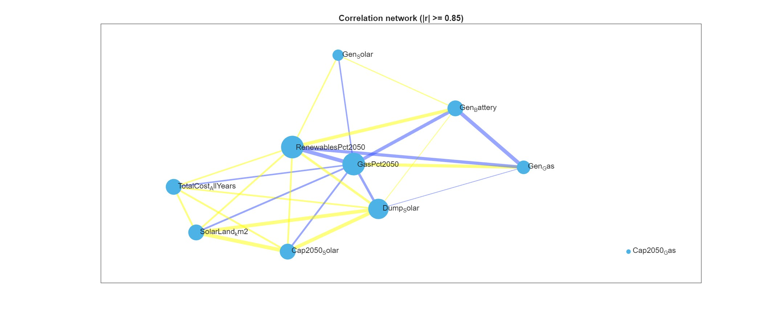
Figure 25 - Correlation network

Appendix D - Simplified water model for Israel

As the water model is only part of a larger model, our goal was to build a simple model that maps the relationships between suppliers and consumers (Figure 1) to enable the prediction of the general trends for water use. The model was developed using data from the Israel Bureau of Statistics, the Water Authority, and Israel's main water-providing company (Mekorot, 2021).
Figure S6: Relationship between water suppliers and consumers
Model component definitions
Desalinated Water, $D\left(t\right)$ – Fresh water that comes from the desalination of sea water and brackish water.
Groundwater, $G\left(t\right)$ – Fresh water from aquifers, wells, springs, streams, and lakes.
Treated Wastewater, $W\left(t\right)$ – Wastewater treated at different levels and is not intended for drinking.
Brackish and Reservoir Water, $B\left(t\right)$ – Water from reservoirs and brackish springs and water stored in reservoirs from floods, which are not intended for drinking.
Home and Industrial, $H\left(t\right)$ – Fresh and non-freshwater consumption for private homes and industries.
Agriculture, $A\left(t\right)$ – Fresh and non-freshwater consumption for agricultural needs.
For Nature, $F.N\left(t\right)$ – Water returned to nature.
For Neighbors, $T.N\left(t\right)$ - Fresh water for consumption outside of Israel.

Model assumptions
• The amount of water provided by the water sources is meets the demand.
• The amount of water that will be used for agriculture will increase linearly in relation to population size.
• Owing to global warming, the amount of natural fresh water will decrease by 25% by 2050.
• The relative amount of fresh water used for agriculture out of the total water used will remain the same as in recent years (35%).
• Water supply to neighboring countries will increase according to the growth of the Palestinian population.
• The amount of wastewater reused is 66%.
• The influence of external events such as changes in prices, imports or exports, and geopolitical events were not considered.
•There is no consideration for economic or physical constraints such as the area required for construction of a desalination plant.
• Modeling depreciation is based on the Water Authority's estimates that the depreciation is approximately 3% of the total consumption.
• The amount of use of brackish and reservoir water will not increase or decrease over the years.

Results. Under the baseline assumptions, total water demand grows from ~2.6 billion m³ in 2023 to ~4.2 billion m³ in 2050, driven largely by demographic growth (population from 9.8 to 16.5 million). Desalination becomes the dominant supply source, increasing from 600 MCM in 2023 to ~1.9 billion m³ in 2050, while natural freshwater declines from ~900 to ~685 MCM. Wastewater reuse rises modestly with demand, while brackish and reservoir water remain constant.

Alternative Scenarios. The model also allows for testing policy-relevant alternatives. For instance, if agricultural expansion capped at +20% by 2050 rather than growing proportionally with population, agricultural water use in 2050 decreases by more than 25% relative to baseline. This reduces desalination requirements by over 10% and mitigates the associated energy and emission burdens. Such analysis highlights the importance of agricultural policy choices for the future balance of the water system.

Model of suppliers and consumers
Our model is based on two components, suppliers, and consumers, where the supplies must meet the demand of the consumers and all components are a function of the target year (t). In the following equation, the consumers are on the right side of the equation, and the suppliers are on the left side:
$D\left(t\right)+G\left(t\right)+W\left(t\right)+B(t)=H\left(t\right)+A\left(t\right)+F.N\left(t\right)+T.N\left(t\right)$, (1)
where for suppliers, D(t) is desalinated water, G(t) is groundwater, W(t) is treated Wastewater, and B(t) is brackish and reservoir water; and for the consumers, H(t) is domestic and industrial fresh water, A(t) is agricultural consumption of fresh water only, F.N(t) is water for neighbors (Jordan, Gaza, and the West Bank), and T.N(t) is water supplied back to nature.

The results of the model according to the above assumptions as follows:
Model results in million cubic meters
2050 | 2040 | 2030 | 2023 | Year
1825 | 1509 | 1248 | 1092 | Home and Industrial | Consumption
2040 | 1744 | 1477 | 1320 | Agricultural | Consumption
277 | 240 | 210 | 193 | Water for Neighbors | Consumption
75 | 50 | 35 | 25 | Water for Nature | Consumption
4217 | 3543 | 2970 | 2630 | Total | Consumption
1820 | 1300 | 874 | 600 | Desalinated Water | Supply
871 | 941 | 1017 | 1070 | Groundwater | Supply
1278 | 1056 | 873 | 765 | Treated Wastewater | Supply
250 |  |  |  | Brackish and Reservoir Water | Supply
4219 | 3547 | 3014 | 2685 | Total | Supply
16.5 | 13.6 | 11.2 | 9.8 | Population size in millions

Model equations
Population growth
Based on the trend in the last 20 years in Israel, the model assumes a population growth of 1.92% (Central Bureau of Statistics, 2019). However, this assumption can change if the user wants to test other scenarios).
$$Pop_{j}=Pop_{0}*{\left(1+p_{g}\right)}^{n},$$ | (2)
where $Pop_{j}$ is the total population in year j, n is the difference in years between the baseline year (2017) and the target year, $p_{g}$ is the yearly change in population, and $Pop_{0}$ is the population in 2017 (8.8 million).
Water consumers
Home and industrial water
On the basis of data (Israel Water Authority, 2022), the water household consumption per capita (h.p.c.) is relatively stable at 110 m³ per year.
Thus, $H\left(t\right)=h.p.c*P\left(t\right)$,
where H(t) is the total water for home and industry, and P(t) is the population size at a given year.

Consumers
Home and Industrial
Home and industrial water consumption includes industrial consumption and therefore includes benign water and marginal water.
The average household consumption of fresh water has been stable over the last decade and a half at approximately 100 m³, including marginal water, which is approximately 110 m³ (Water Authority, 2022).
Fresh water accounts for 89% of the total home and industrial consumption per capita.
The consumption equation is as follows:
$$H\left(t\right)=h.p.c*P\left(t\right)$$
- H – the amount of home and industrial consumption in million cubic meters
- t – time, years
- h.p.c. - average household consumption per capita in cubic meters
- P – population size in millions
Agricultural Consumption
Agricultural consumption is calculated according to the size of the population and average consumption per capita for agriculture, which currently stands at approximately 136 m³ per capita for each year, of which approximately 65% is non-fresh water and the remaining is fresh water (Water Authority, 2022).
The average agricultural consumption per capita has been decreasing consistently in the last two decades. Based on the data from the Water Authority, the following prediction equation for average consumption per capita (a.p.c.) was fitted:
$a.p.c(t)= -10.79*\ln\left(t\right)+168.17 ; t>0$ ; t = 1 marks the year 2001 and so on. (3)
An R² value of 0.86 indicates a good fit to the data.
Using Equation 3, the total water for agricultural, A(t), is predicated:
$$A\left(t\right)=a.p.c*P(t)$$
Water for Neighbors
Water for neighbors is measured according to the quantities of water supplied to Jordan and the Palestinians and constitutes approximately 7% of Israel's total freshwater consumption.
The supply of water to Jordan is dictated by periodic agreements. Currently, 90 million m³ is supplied (Water Authority, 2022).
The supply of water to the Palestinians is also determined by agreements, but often with deviations where a quantity higher than agreed is provided.
On the basis of the behavior of the water supply to neighbors, in this model, we calculate the amount of water according to the growth of the Palestinian population only and by known agreements concluded with Jordan.
$$F.N\left(t\right)=p.p.c*P.P\left(t\right)+J$$
• F.N. – the amount of water for the neighbors in the MLC
• t – time, years
• p.p.c - average Palestinian consumption per capita supplied by Israel
• P.P - Palestinian population size in millions (Worldmeter, 2023)
• J - The amount of water supplied to Jordan according to an updated agreement.
Water for Nature
Water for nature is water returned into streams for various reasons such as ecology and infrastructure.
This water constitutes, on average, approximately 1% of the total consumption, and it is composed of fresh and non-fresh water (Water Authority, 2022).
In our model, we used past data and a schematic forecast from the Mekorot company (Mekorot, 2021).

Table 18 - Amount of water for nature in million cubic meters
Water consumption for nature in million cubic meters
2050 | 2040 | 2030 | 2023
75 | 50 | 35 | 25

Suppliers
Desalinated Water
As Israel is a relatively dry country, we assumed that the role of desalinated water is to bridge the gap between demand and supply. Therefore, this is how the required amounts of desalination are calculated (Water Authority, 2022).
Thus, we rearranged Equation 1 to forecast the amount of desalinated water required:
$$D\left(t\right)=0.89*H\left(t\right)+0.35*A\left(t\right)+F.N\left(t\right)+T.N\left(t\right)-G\left(t\right)$$
where for suppliers, D(t) is desalinated water and G(t) is ground water; and for consumers, H(t) is domestic and industrial fresh water only, A(t) is agricultural consumption of fresh water only, F.N(t) is water for neighbors (Jordan, Gaza, and the West Bank), and T.N(t) is water supplied to nature.

Groundwater
Owing to climate change, the supply of ground water is expected to decrease in the future because of a consistent decrease in the amount of precipitation, which makes it difficult to fill the water reservoir from which groundwater is drawn (Water Authority, 2022).
According to a forecast by the Mekorot company, by the year 2050, there will be a 5 percent decrease in the amount of precipitation, and this will reduce the filling volume in aquifers, lakes, etc. between 20 and 30 percent (Mekorot, 2021).
Therefore, in our model, we calculate a decrease in ground water supply in a linear manner with a target of a 25 percent reduction in natural water use in 2050.
Treated Wastewater
The percentage of the amount of wastewater that is reused has been relatively consistent in recent years at approximately 66% of the water supplied to homes and industries. However, this might change in the future because of technological improvements. In our model, we used 66% in the calculations. This water is currently used mostly for agriculture; therefore, in this scenario, we assume that there will be an increase in the use of water for agricultural purposes proportional to the population growth.

Brackish and Reservoir Water
Brackish water is a supplementary water source for various requirements where it mainly supports agricultural consumption. In recent years, the use of brackish water averages 220 million m³ per year.
Reservoir water is not fresh water used for a variety of uses such as water for agriculture and nature. The amount of this water varies according to the amount of annual precipitation and therefore cannot be predicted. In recent years, the use of this water has averaged 30 million m³ per year.
For brackish water, there is no plan to increase the pumping, which is relatively constant. Therefore, we chose to consider the amount of both brackish and reservoir water as a fixed figure of 250 million m³ per year (Mekorot, 2021).
References
- Water consumption in Israel 2021 (Water Authority,(2022
- Production and consumption of water (Central Bureau of Statistics, 2022)
- The Israeli population forecast (Central Bureau of Statistics, 2019)
- Palestinian population growth forecast (Worldometer, 2023)
- The water forecast in Israel (Mekorot, 2021)

Energy Use and Emissions.
A distinctive feature of the model is its link to the broader environmental framework, by explicitly incorporating the energy requirements and related GHG emissions of water provision. For example, desalinating 1 m³ of seawater requires ~3.5 kWh of electricity, pumping 1 m³ from natural sources ~0.5 kWh, and wastewater treatment ~0.65 kWh. These coefficients make the water model an integral part of the national carbon footprint analysis, connecting water demand not only to physical resources but also to energy use and emissions.

Appendix E - NZO API: Structure of Retrieved Data
Category | Fields Returned
Meta information | name, year
Installed capacities | solarCapacity, windCapacity, storageEnergy
Generation by source | coalGeneration, gasGeneration, solarGeneration, windGeneration
System indicators | storageUsage, renewableConsumption, renewableShare, curtailedEnergy
Economic outputs (NPV) | externalitiesCummulativeNPV, solarTotalCummulativeNPV, windTotalCummulativeNPV, storageTotalCummulativeNPV, gasTotalCummulativeNPV, totalCostCummulativeNPV

תקציר בעברית
התמודדות עם שינויי האקלים מחייבת דה־קרבוניזציה מהירה של מערכות ייצור החשמל הלאומיות, אולם מסלולי המעבר האפשריים מושפעים במידה רבה מאילוצים מבניים כלכליים, מרחביים וסביבתיים. ישראל מהווה מקרה בוחן ייחודי בהקשר זה, בשל שילוב של גידול דמוגרפי מואץ, יעדי אקלים שאפתניים, ומגבלות חריפות של זמינות קרקע. בהסתמך על מודל מסגרת לקיימות לאומית, תזה זו מפתחת מודל אופטימיזציה למערכת החשמל בישראל ברזולוציה שעתית (כ־245,000 צעדי זמן, לשנים 2023–2050). הבעיה מנוסחת כבעיית תכנות ליניארי רחבת היקף, שמטרתה מזעור פליטות גזי חממה מצטברות, בכפוף לאילוצים על זמינות קרקע סולארית, עלות מערכתית, דינמיקת אגירה ומגבלות תפעוליות.

התוצאות מראות באופן עקבי כי ייצור סולארי ואגירת אנרגיה בבטריות מהווים את הגורמים המרכזיים המאפשרים חדירה גבוהה של אנרגיות מתחדשות, בעוד שייצור מבוסס גז טבעי נותר כגורם איזון שיורי. שיעורי מתחדשות של כ־70–80% נמצאים כברי השגה מבחינה טכנית וכלכלית תחת ההנחות הנוכחיות. לעומת זאת, דחיפה מעבר לכ־90% מתחדשות כרוכה בהרחבה בלתי פרופורציונלית של תשתיות וקרקע סולארית במסגרת ההנחות והאילוצים שנבחנו במחקר זה, ומלווה בעלייה בעלויות המערכת וברמות אובדן אנרגיה. כאשר נבחנות רק העלויות הישירות של המערכת, תצורות מבוססות דלקים פוסיליים נראות זולות משמעותית ממערכות עתירות מתחדשות. עם זאת, כאשר נכללות במפורש העלויות החיצוניות של זיהום אוויר ופליטות גזי חממה, העלות הכוללת של מסלולים פוסיליים מתקרבת לרמות העלות של מערכות המגיעות לכ־90% מתחדשות. ממצא זה מדגיש כי יתרון העלות לכאורה תלוי בהרכב העלויות ובשיטת החשבונאות, ולא בהיקף ההוצאה הכולל בלבד.

לצורך מיקוד הניתוח בתצורות מערכת סבירות מבחינה כלכלית, נבחנה תת קבוצה של תרחישים המאופיינים בעלות מערכת ממוצעת נמוכה יחסית בכל רמת חדירה של מתחדשות. ניתוח זה מראה כי שיקולי יעילות כלכלית מגבילים בעיקר את קנה המידה של המערכת, כגון היקף התשתיות והקיבולות הנדרשות, ולא את ההרכב הבסיסי של טכנולוגיות הייצור. בכל התצורות היעילות כלכלית נשמר תפקיד דומיננטי לייצור סולארי, אגירה בבטריות ואיזון באמצעות גז, כאשר ההבדלים בעלות נובעים בעיקר מהיקף הפריסה ולא מהחלפת טכנולוגיות.

ניתוח רגישות מצביע על כך שזמינות משולבת של תקציב וקרקע סולארית מהווה את הגורם המגביל המרכזי להשגת שיעורי מתחדשות גבוהים מאוד. במסגרת מרחב התרחישים שנבחן, סביב רמת חדירה של כ־90% המתאימה להקצאה של כ־700–900 קמ"ר של קרקע סולארית ולתקרת עלות מערכתית בסדר גודל של (8–10)×10¹¹ ש"ח, הקלה באילוץ אחד בלבד אינה מאפשרת עלייה משמעותית נוספת בחדירת המתחדשות. מעבר לנקודה זו, תוספת תקציב ללא הרחבת קרקע, או הרחבת קרקע ללא גמישות תקציבית מקבילה, מניבה שיפורים שוליים בלבד. ממצאים אלו מדגישים את האופי המוצמד של האילוצים הכלכליים והמרחביים במסלולי דה־קרבוניזציה עמוקה.

תרומתה של תזה זו היא תלת ממדית: מבחינה מתודולוגית, היא מדגימה כיצד מודלים של אופטימיזציית מערכות חשמל יכולים להרחיב מסגרות קיימות של טביעת רגל סביבתית לכלי תומך החלטות תפעולי; מבחינה אמפירית, היא מספקת תובנות מקוריות ברמת המערכת לגבי מעבר משק החשמל בישראל תחת שילוב של אילוצים; ומבחינה אנליטית, היא מבהירה את התפקיד המשולב של קרקע, עלות ופליטות בעיצוב מסלולים אפשריים ויעילים לדה־קרבוניזציה. אף שישראל מהווה מקרה ייחודי בהיקפו ובמאפייניו, התנאים המבניים שלה – זמינות קרקע מוגבלת, ביקוש הולך וגדל ויעדי אקלים שאפתניים – משקפים אתגרים המשותפים למדינות רבות, ומקנים לממצאים רלוונטיות מעבר למקרה הבוחן הספציפי.

אוניברסיטת בן גוריון בנגב
הפקולטה למדעי ההנדסה
המחלקה לתעשייה וניהול

ניתוח משולב ואופטימיזציה של
מערכת טביעות רגל סביבתיות לאומיות קיימות וצפויות

מאת: דור חן
מנחה: פרופ' רזיאל רימר ופרופ' מידד קיסנג'ר

חתימת המחבר: דור חן תאריך: 28.9.2025
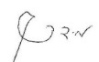
אישור המנחה: פרופ' רזיאל רימר תאריך: 28.9.2025
אישור המנחה: פרופ' מידד קיסינגר תאריך: 29.9.2025
אישור יו''ר ועדת תואר שני מחלקתית: פרופ' גלעד רביד תאריך: 30.9.2025

ספטמבר 2025

אוניברסיטת בן גוריון בנגב
הפקולטה למדעי ההנדסה
המחלקה לתעשייה וניהול

ניתוח משולב ואופטימיזציה של
מערכת טביעות רגל סביבתיות לאומיות קיימות וצפויות

מאת: דור חן
מנחים: פרופ' רזיאל רימר ופרופ' מידד קיסנג'ר

ספטמבר 2025

